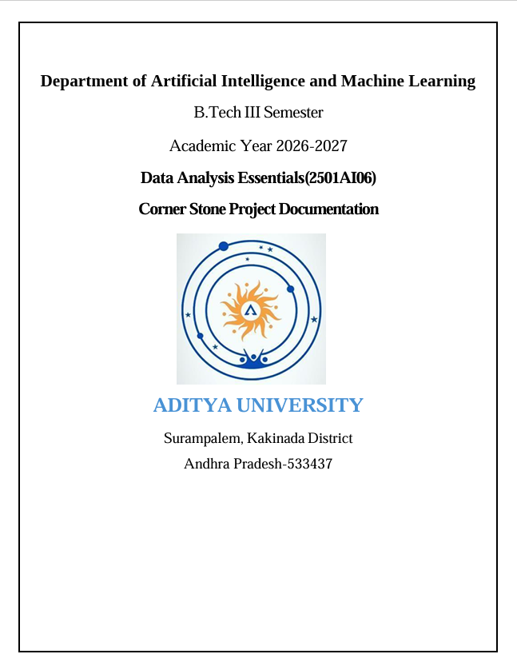

ADITYA UNIVERSITY
School of Computing
Department of Artificial Intelligence and Machine Learning
DATA ANALYSIS ESSENTIALS
Certificate
This is to certify that the Cornerstone project work entitled “WEATHER DATA ANALYSIS”
is submitted by
K. Bhagya Rekha (25B11AI506)
S. Praharshitha (25B11AIA70)
P. Satya (25B11AI995)
S. Ruhee (25B11AIA84)

in partial fulfilment of the requirements for the award of the B.Tech. degree in Artificial intelligence and machine learning the academic year 2026-2027.

Project Guide Head of the Department
B. Sai Venkata Ganesh Dr. K. Naga Bhargavi, Ph.D,
Assistant Professor, Associate Professor & HOD
Department of AIML Department of AIML

CERTIFICATE
This is to certify that the project work entitled “WEATHER DATA ANALYSIS” is submitted by K. Bhagya Rekha (25B11AI506), S. Praharshitha (25B11AIA70), P. Satya (25B11AI995), and S. Ruhee (25B11AIA84), in partial fulfilment of the requirements for the award of the B.Tech. degree in Artificial Intelligence and Machine Learning during the academic year 2026–2027.
The project has been carried out under the guidance of B. Sai Venkata Ganesh and demonstrates the application of data collection, data cleaning, exploratory data analysis, time-series analysis, and data visualization techniques.

Project Guide: B. Sai Venkata Ganesh
Department of AIML

DECLARATION
We hereby declare that the project entitled “WEATHER DATA ANALYSIS” is our original academic work and is submitted to ADITYA UNIVERSITY, Surampalem, in partial fulfilment of the requirements for the award of the B.Tech. degree in Artificial Intelligence and Machine Learning.
We further declare that this project work has not been submitted, either in full or in part, for the award of any degree or diploma in this or any other institution. We confirm that the work has been carried out with academic honesty and that the analysis and visualizations presented in this documentation are prepared for academic purposes.

Place: Surampalem
Date: 27-09-2026

K. Bhagya Rekha (25B11AI506)
S. Praharshitha (25B11AIA70)
P. Satya (25B11AI995)
S. Ruhee (25B11AIA84)

ACKNOWLEDGEMENT
We express our sincere gratitude to our project guide, B. Sai Venkata Ganesh, for his valuable guidance, encouragement, and suggestions throughout the development of the Weather data analysis. His support helped us understand the practical application of data analysis concepts.
We also thank the Department of Artificial Intelligence and Machine Learning and the faculty members of Aditya University for providing the academic environment, laboratory facilities, and resources required to complete this project.
Finally, we thank our classmates, friends, and everyone who supported us directly or indirectly during the collection, processing, analysis, and presentation of the project.

ABSTRACT
The Weather Data Analysis System is a Python-based data analysis project developed to clean, process, analyze, and visualize weather data effectively. Raw weather data may contain missing values, duplicate records, and inconsistent formats, making it difficult to obtain meaningful information. The proposed system uses Python libraries such as Pandas, NumPy, and Matplotlib to preprocess the dataset and prepare it for analysis.
The system performs data inspection, removes duplicate records, handles missing values using suitable statistical methods, converts date values into proper formats, and sorts the data chronologically. It also calculates minimum, maximum, and average temperature and humidity values and identifies the most common weather condition. Temperature conversion between Celsius and Fahrenheit is also implemented.
Various visualizations, including temperature trends, temperature distributions, weather-condition frequencies, and seasonal patterns, are used to understand the data more clearly. The system successfully transforms raw weather data into meaningful statistical insights and visual patterns. The results can help in understanding weather trends and provide a foundation for future weather forecasting and machine learning applications.

TABLE OF CONTENTS
1 Introduction
1.1 Introduction to the Project
1.2 Problem Statement
1.3 Objectives of the Project
1.4 Scope of the Project
1.5 Motivation for the Project
1.6 Organisation of the Documentation
1.7 Overview of the Technologies Used
1.8 The Data Analysis Life Cycle
2 Dataset Description and Understanding
2.1 Dataset Source
2.2 Dataset Description
2.3 Features / Attributes
2.4 Target Variable
2.5 Dataset Statistics / Initial Exploration
2.6 Data Quality Assessment
2.7 Ethical Use and Licence of the Data
3 Data Preprocessing
3.1 Data Collection / Loading
3.2 Handling Missing Values
3.3 Handling Duplicate / Inconsistent Data
3.4 Date and Time Processing
3.5 Project-Specific Preprocessing
3.6 Summary of Preprocessing Steps
3.7 Data Transformation and Aggregation
3.8 Validation After Preprocessing
4 System Design and Methodology
4.1 Proposed Methodology
4.2 System Workflow / Architecture
4.3 Flowchart
4.4 Tools and Technologies Used
4.5 Analysis Methods Used
4.6 Software and Hardware Requirements
4.7 Modular Design
4.8 Dashboard Layout Design
5 Implementation
5.1 Development Environment
5.2 Dataset Loading and Exploration
5.3 Preprocessing Implementation
5.4 Exploratory Data Analysis
5.5 Time-Series and Geographic Analysis
5.6 Important Code Explanation
5.7 Testing and Validation
5.8 Common Errors and Their Solutions
6 Data Visualization and Results
6.1 Line Chart
6.2 Bar Graph
6.3 Histogram
6.4 Scatter Plot
6.5 Line graph (monthly average)
6.6 Interpretation of Visualizations
6.7 Dashboard View
6.8 Preparing Charts for Black-and-White Printing
7 Analysis of Results
7.1 Analysis Approach
7.2 Observed Patterns
7.3 Result Interpretation
7.4 Discussion
7.5 Answers to the Analysis Questions
7.6 Comparison of Chart Types Used
7.7 Limitations of the Interpretation
8 Output Screenshots
8.1 Dataset Screenshots
8.2 Preprocessing Outputs
8.3 Statistical Analysis Outputs
8.4 Visualization Outputs
8.5 Dashboard Outputs
8.6 Runtime Temperature Conversion Outputs
9 Conclusion and Future Enhancements
9.1 Conclusion
9.2 Limitations
9.3 Future Enhancements
9.4 Learning Outcomes
9.5 Final Remarks
9.6 Summary of Objectives and Outcomes
10 References
11 Appendix – Source Code
Appendix B – Glossary of Terms
12 Future Enhancements

Chapter 1: Introduction

1.1 Introduction to the Project
Weather plays an important role in our daily lives and affects areas such as agriculture, transportation, tourism, and disaster management. Weather data contains information such as date, temperature, humidity, and weather conditions. However, raw weather data may contain missing values, duplicate records, and inconsistent formats, making it difficult to analyze directly.
The Weather Data Analysis System uses Python to clean, preprocess, and analyze weather data. Pandas and NumPy are used for data processing, while Matplotlib is used to create graphs and visualizations. The system calculates temperature and humidity statistics, performs temperature conversion, and identifies weather patterns and temperature trends through charts and statistical analysis.

1.2 Problem Statement
Weather data is often available in raw and inconsistent forms, containing missing values, duplicate records, and improper data formats, making it difficult to analyze temperature, humidity, and weather conditions. The problem is to develop a system that cleans and preprocesses the raw weather data, performs statistical analysis, and uses visualizations to identify important weather patterns, temperature trends, and meaningful insights from the dataset.

1.3 Objectives of the Project
- To collect and load weather data from a CSV dataset.
- To clean the dataset by handling missing values and removing duplicate records.
- To preprocess the data by converting dates into proper formats and organizing the records.
- To perform statistical analysis of temperature and humidity values.
- To identify weather patterns and the most common weather conditions.
- To visualize weather data using graphs such as line charts, histograms, and bar charts.
- To visualize weather data using graphs such as line charts, histograms, and bar charts.
- To convert temperature values between Celsius and Fahrenheit for better understanding.

1.4 Scope of the Project
The scope of the Weather Data Analysis System includes collecting, cleaning, preprocessing, and analyzing weather data containing date, temperature, humidity, and weather conditions. The system handles missing and duplicate values, performs statistical analysis, converts temperatures between Celsius and Fahrenheit, and uses graphs to identify temperature trends, seasonal variations, and common weather patterns. The project can also serve as a foundation for future weather forecasting and machine learning applications.

1.5 Motivation for the Project
The motivation behind developing the Weather Data Analysis System is to address the challenge of extracting meaningful information from raw and inconsistent weather data. Weather datasets contain important parameters such as temperature, humidity, date, and weather conditions, but missing values, duplicate records, and inconsistent formats can affect the accuracy and efficiency of analysis. The project is therefore motivated by the need to apply systematic data cleaning and preprocessing techniques before performing analysis.
Furthermore, the project aims to demonstrate how statistical analysis and data visualization can transform processed weather data into clear and useful insights. By analyzing temperature trends, weather conditions, distributions, and seasonal variations, the system provides a better understanding of weather patterns. It also strengthens practical knowledge of Python-based data analysis and provides a foundation for extending the system toward future weather forecasting and machine learning applications.

1.6 Organisation of the Documentation
The documentation is divided into eleven chapters. Chapter 1 introduces the project, including the background, problem statement, objectives, scope, and motivation. Chapter 2 describes the weather dataset and its attributes. Chapter 3 explains the data preprocessing steps, including handling missing values, removing duplicates, and converting dates into the required format. Chapter 4 presents the system design and methodology, including the workflow, tools, and techniques used. Chapter 5 explains the implementation of the project step by step. Chapter 6 presents the data visualizations and their interpretation. Chapter 7 discusses the analysis and key results obtained from the dataset. Chapter 8 contains screenshots of the project outputs. Chapter 9 presents the conclusion, limitations, and future enhancements. Chapter 10 provides the references, and Chapter 11 contains the complete source code.
Chapter | Title | Purpose
1 | Introduction | Background, problem statement, objectives scope and motivation
2 | Dataset Description and Understanding | Dataset source, structure, files and attributes
3 | Data Preprocessing | Cleaning, missing values, duplicates, date conversion
4 | System Design and Methodology | Workflow, flowcharts, tools, methods
5 | Implementation | Step-by-step code and implementation process
6 | Data Visualization and Results | Line graphs, histograms, bar charts and other visualizations
7 | Analysis of Results | Weather patterns, temperature trends and interpretation
8 | Output Screenshots | Screenshots of outputs
9 | Conclusion and Future Enhancements | Summary, limitations, future scope
10-11 | References and Appendix | Sources and complete source code

1.7 Overview of the Technologies Used
Before starting the analysis, the team studied the tools that are used in the project. A short overview of each tool is given below.
1.7.1 Python
Python is the primary programming language used to develop the Weather Data Analysis System. It is used to perform the complete data analysis process, including loading the dataset, cleaning and preprocessing the data, performing statistical calculations, converting temperature values, and generating results. Its simple syntax and availability of data analysis libraries make it suitable for implementing the project.
1.7.2 Pandas
Pandas is a Python library used mainly for handling and processing the weather dataset. In this project, it is used to read the climate_code.csv file, inspect the data, identify missing values and duplicate records, remove duplicates, fill missing values, convert the date column into the required format, and organize the cleaned dataset for further analysis.
1.7.3 Matplotlib
Matplotlib is a Python visualization library used to represent the analyzed weather data graphically. In this project, it is used to create visualizations such as temperature trend line graphs and temperature distribution histograms. These graphs make it easier to identify changes, patterns, and variations in the weather data.
1.7.4 NumPy
NumPy is a Python library used for numerical and mathematical operations. In this project, it supports the processing of numerical weather data such as temperature and humidity. It helps in performing efficient numerical calculations required during the statistical analysis of the dataset.
1.7.5 Google Colab
Google Colab is used as the development and execution environment for the project. It provides an interactive platform where Python code can be written and executed, datasets can be uploaded, and analysis results and visualizations can be displayed. In the project, the CSV file is uploaded using files.upload() and loaded using Pandas.
1.7.6 CSV Dataset
The CSV dataset, climate_code.csv, is the primary data source used in the project. It contains weather-related information such as Date, Temperature, Humidity, and Weather. The dataset is inspected, cleaned, and preprocessed before statistical analysis and visualization are performed.
Tool | Category | Role in the project
Python | Programming language | Writes the analysis code
Pandas | Library | loading, cleaning, preprocessing, grouping, and analyzing the dataset
Matplotlib | Library | Used to create graphs and charts for data visualization
NumPy | Library | numerical and mathematical operations on weather data
Colab | Environment | Running code and viewing output
CSV | File format | Storage format of the dataset

1.8 The Data Analysis Life Cycle
Every data analysis project passes through a sequence of stages. This project follows the same life cycle.
Stage 1 – Define the problem. Identify the challenges in analyzing raw weather data and determine how to understand temperature trends, humidity levels, and weather conditions.
Stage 2 – Collect the data. Obtain the weather dataset, climate_code.csv, containing date, temperature, humidity, and weather condition information.
Stage 3 – Clean the data. Remove duplicate records, handle missing temperature and humidity values using the median, fill missing weather conditions using the mode, and correct invalid date values.
Stage 4 – Explore and analyse the data. Calculate minimum, maximum, and average temperature and humidity values. Identify the most common weather condition and examine weather patterns.
Stage 5 – Visualise the data. Create line graphs, histograms, and other charts using Matplotlib to display temperature trends, temperature distribution, humidity variations, and weather condition frequency.
Stage 6 – Interpret and communicate. Explain the patterns observed in the graphs and statistical results, identify temperature variations and weather trends, and present the findings in the project report and presentation.

Chapter 2: Dataset Description and Understanding

2.1 Dataset Source
The dataset used in this project was obtained as a CSV file named climate_code.csv for the Weather Data Analysis System. The dataset contains weather-related information, including date, temperature, humidity, and weather conditions. It serves as the primary source of data for analyzing weather patterns and identifying temperature variations over time. The dataset is loaded into Python using the Pandas library, which allows us to inspect the records, understand the columns, and perform data cleaning and preprocessing. The selected dataset helps our team calculate temperature and humidity statistics, visualize weather trends, and identify common weather conditions. These insights are presented using statistical analysis and graphical visualizations to improve our understanding of weather patterns.
2.1.1 Step-by-Step Process Followed to Obtain the Dataset
The following steps were carried out by the team to obtain the weather dataset and prepare it for analysis. The same steps can be summarised in the flowchart shown in Fig. 2.1.
Step 1: Identify the dataset. A weather dataset named climate_code.csv was selected for the Weather Data Analysis System.
Step 2: Obtain the dataset. The CSV file containing weather information was obtained and saved on the computer for further processing.
Step 3: Verify the dataset file. The dataset file was checked to ensure that it was available in CSV format and could be loaded into the Python environment.
Step 4: Prepare the working environment. Google Colab was opened, and the required Python libraries, including Pandas, NumPy, and Matplotlib, were used for data analysis.
Step 5: Upload the dataset. The climate_code.csv file was uploaded to Google Colab using the file upload option.
Step 6: Load the dataset in Python. The dataset was loaded into a Pandas DataFrame using the pd.read_csv() function.
Step 7: Display the dataset records. The head() function was used to display the first five records and understand the structure and contents of the dataset.
Step 8: Inspect the dataset. The number of rows and columns, missing values, duplicate records, and data types were examined to understand the quality of the data.
Step 9: Begin data cleaning and preprocessing. Duplicate records were removed, missing values were handled, invalid dates were excluded, and the dataset was sorted by date to prepare it for statistical analysis and visualization.
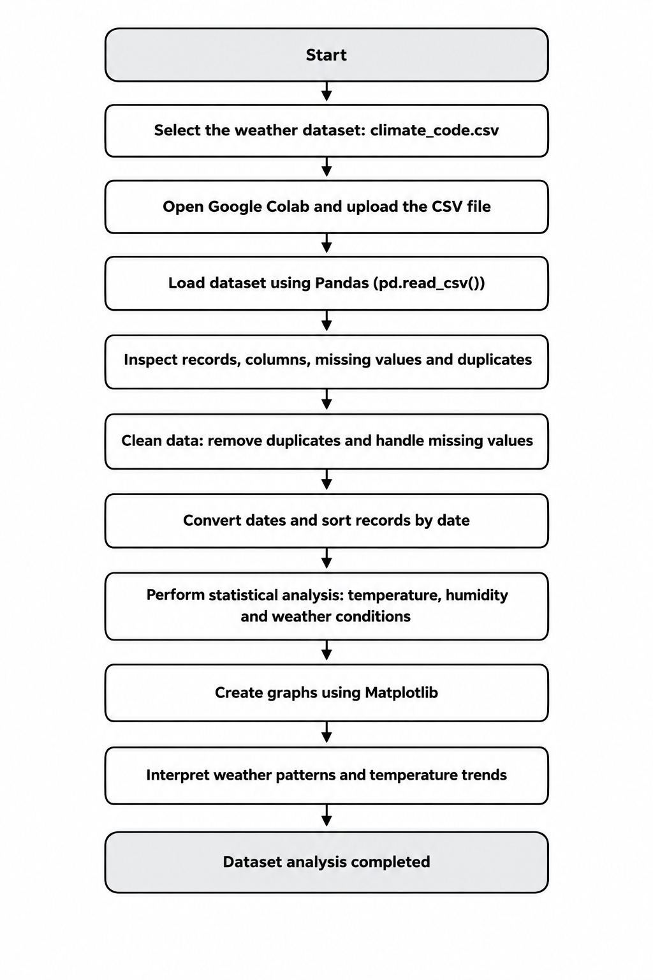
Fig 2.1: Steps to Obtain and Prepare the Weather Dataset
2.1.2 Files Available in the Dataset
The dataset used in this project is climate_code.csv. It contains weather-related information used to study temperature variations, humidity levels, and weather conditions. The dataset is processed using Python libraries to perform statistical analysis and generate graphical visualizations.
Column name | Level of data | Used for
Date | Date of each weather record | Analysing weather trends over time
Temperature | Temperature in degrees Celsius | Calculating minimum, maximum, and average temperatures
Humidity | Humidity level in percentage | Analysing humidity variations
Weather | Recorded weather condition | Identifying common weather conditions and their frequency

2.2 Dataset Description
The dataset used in this project contains weather observations that can be analysed over time. The main attributes recorded are date, temperature, humidity, and weather conditions. These attributes help in understanding temperature variations, humidity levels, common weather conditions, and changes in weather patterns over time.
The data is stored in CSV (Comma Separated Values) format in a file named climate_code.csv. A CSV file is a plain text file in which each line represents a record and the column values are separated by commas. This format is lightweight, easy to manage, and can be opened in spreadsheet applications or read directly using the Pandas library in Python.
2.2.1 Characteristics of the Dataset
- Format: CSV (Comma Separated Values), stored in the file climate_code.csv.
- Type of data: Numerical data (temperature and humidity), a date field, and categorical data (weather conditions).
- Coverage: Multiple weather records containing dates, temperature values, humidity levels, and weather conditions.
- Use in this project: Data cleaning, descriptive and exploratory analysis, statistical calculations, and visualization of weather patterns. No prediction model is trained in this project.

2.3 Features / Attributes
The important attributes of the dataset, their data types and their meaning are given below. These attributes are used for data cleaning, statistical calculations, trend analysis, grouping, and visualization.
Attribute | Type | Description
Date | Date | Date on which the weather observation was recorded
Temperature | Numeric (float) | Temperature recorded in degrees Celsius
Humidity | Numeric (float) | Humidity level recorded as a percentage
Weather | Categorical (text) | Weather condition recorded, such as sunny, rainy, or cloudy

2.3.1 Categorical and Numerical Attributes
The categorical attribute, Weather, is used to group records according to different weather conditions and identify the most common condition. The numerical attributes, Temperature and Humidity, are used to calculate minimum, maximum, and average values and study variations in weather measurements. The Date attribute is used to arrange records chronologically and perform time-series analysis. Together, these attributes help identify temperature trends, humidity variations, and patterns in weather conditions.

2.4 Target Variable
A target variable is not applicable to this project because the Weather Data Analysis System is a statistical data analysis and visualization project rather than a supervised machine-learning prediction model. The numerical weather attributes, such as Temperature and Humidity, are used for statistical calculations and identifying weather patterns rather than predicting a specific output. Therefore, no single target variable is defined for this project.

2.5 Dataset Statistics / Initial Exploration
Initial exploration of the weather dataset involves examining its structure, size, data types, missing values, duplicate records, descriptive statistics, and sample records. The dataset climate_code.csv is loaded into a Pandas DataFrame, and functions such as head(), info(), describe(), isnull().sum(), and duplicated().sum() are used for this stage. These functions help understand the dataset, identify data quality issues, and determine whether cleaning and preprocessing are required before performing statistical analysis and visualization.
2.5.1 Commands Used for Initial Exploration
import pandas as pd

df = pd.read_csv("climate_code.csv")

print(df.shape) # number of rows and columns
print(df.columns) # names of all columns
print(df.head()) # first five records
df.info() # data types and non-null counts
print(df.describe()) # Generate descriptive statistics
print(df.isnull().sum()) # missing values in every column
print(df.duplicated().sum()) # number of duplicate rows
print(df.tail()) # display the last 5 records

Command | What it tells us
df.shape | Total number of rows and columns
df.columns | Names of all the columns
df.head() | Sample of the first records to verify loading
df.info() | Data type of each column and count of non-null values
df.describe() | Shows statistical summaries of numerical columns
df.isnull().sum() | Number of missing values in each column
df.duplicated().sum() | Number of repeated rows
Df.tail() | Display the last 5 rows

2.5.2 Observations from Initial Exploration
- The dataset contains numerical columns such as Temperature and Humidity, allowing mathematical calculations and statistical analysis.
- The Date column is converted into the datetime format to support chronological sorting and time-series analysis.
- The dataset is used for statistical analysis and visualization, with no target variable defined for classification or regression modelling.
- The Weather column contains categorical values that allow weather conditions to be grouped, compared, and analysed to identify the most common weather patterns.

2.6 Data Quality Assessment
Before using a dataset, its quality must be judged. Data quality is checked using five common dimensions.
Dimension | Meaning | How it was checked
Completeness | Are all required values present? | df.isnull().sum()
Uniqueness | Are there repeated records? | df.duplicated().sum()
Consistency | Are names and formats uniform? | Checking unique weather values and ensuring consistent date formats
Validity | Are values of the correct type and range? | df.info(), df.describe()and checking for invalid temperature or humidity values
Timeliness | Does the data cover the required period? | Minimum and maximum of the Date column

The data quality assessment helps identify missing values, duplicate records, inconsistent formats, invalid measurements, and date-related issues that may affect the analysis. For example, humidity values outside the range of 0% to 100% should be examined, and invalid dates should be corrected or removed. These checks help prepare a reliable dataset for further analysis and visualization.

2.7 Ethical Use and Licence of the Data
Every dataset has a licence that specifies how it can be used, modified, and shared. The weather dataset used in this project, named climate_code.csv, contains weather-related information such as date, temperature, humidity, and weather conditions. The dataset is used for academic learning and analysis without involving personal or sensitive information.
The data is processed and analysed using Python libraries to identify weather patterns and generate meaningful insights. The results are presented through statistical summaries and visualizations, and the dataset source should be acknowledged in the project references. The findings are interpreted based on the available data and are not presented as precise weather forecasts or scientific conclusions beyond the scope of the analysis.

Chapter 3: Data Preprocessing

3.1 Data Collection / Loading
Data collection for the Weather Data Analysis System was completed by obtaining the weather dataset named climate_code.csv. The dataset was loaded into a Pandas DataFrame using Python. A DataFrame is a two-dimensional table with labelled rows and columns and is the main data structure used in Pandas for storing, processing, and analysing structured data.
3.1.1 Steps Followed for Loading the Data
- Import the Pandas library.
- Upload the climate_code.csv file to Google Colab.
- Use the pd.read_csv() function to read the CSV file.
- Store the loaded data in a DataFrame variable named df.
- Display df.head() and df.shape to verify that the dataset was loaded correctly.
- Check the column names, data types, and missing values to identify any loading issues.
import pandas as pd
from google.colab import files
uploaded = files.upload()
df = pd.read_csv("climate_code.csv")
print("First five records:")
print(df.head())
print("Dataset shape:", df.shape)
print("Column names:", df.columns.tolist())
df.info()

If the notebook is executed in Google Colab, the CSV file must first be uploaded using the file upload option. If the notebook is executed locally in Jupyter Notebook, the CSV file should be kept in the same folder as the notebook, or the full file path should be specified. Once the dataset is loaded successfully, it is ready for inspection, data cleaning, preprocessing, and further analysis.

3.2 Handling Missing Values
Missing values are entries that are empty in the weather dataset. They can affect statistical calculations, temperature trends, and visualizations. Missing values are identified using df.isnull().sum(), which gives the number of empty cells in each column. In this project, missing temperature and humidity values are filled using the median, while missing weather conditions are filled using the mode.
3.2.1 Methods of Treating Missing Values
Method | When it is used | Pandas function
Drop rows | When only a few rows are affected and they cannot support the analysis | df.dropna()
Fill with 0 | When a missing count means that no case was reported | df.fillna(0)
Fill with mean / median | When the column is numeric and a typical value is acceptable | df[col].fillna(df[col].median())
Keep as it is | When the column is not used in the analysis | —

# identify missing values
print("Missing values before treatment:")
print(df.isnull().sum())
# Fill missing numerical values using median
df["Temperature"] = df["Temperature"].fillna( df["Temperature"].median() )
df["Humidity"] = df["Humidity"].fillna( df["Humidity"].median() )
# Fill missing categorical values using mode
df["Weather"] = df["Weather"].fillna( df["Weather"].mode()[0] )
# Check missing values after treatment
print("\nMissing values after treatment:") print(df.isnull().sum())

The treatment method is selected according to the meaning and data type of each column. Median values are used for missing temperature and humidity measurements, while the mode is used for missing weather conditions. This approach helps prepare the dataset for reliable statistical analysis and visualization.

3.3 Handling Duplicate / Inconsistent Data
Duplicate records are rows that appear more than once with identical values. They can affect statistical calculations and lead to misleading results during data analysis. The number of duplicate rows in the weather dataset is identified using df.duplicated().sum(), and duplicate records are removed using df.drop_duplicates().
print("Duplicates before:", df.duplicated().sum())
df = df.drop_duplicates()
print("Duplicates after :", df.duplicated().sum())

# make column names consistent
country_df.columns = df.columns.str.strip()
# Remove extra spaces from weather condition values
df["Weather"] = df["Weather"].str.strip()
# Display the cleaned column names
print("Column names:", df.columns.tolist())

Inconsistent formatting, such as extra spaces in column names or weather condition values, can create difficulties during grouping and analysis. Therefore, column names and text values are checked and standardized. Removing duplicate records and correcting formatting helps maintain data consistency and improves the reliability of statistical calculations and visualizations.

3.4 Date and Time Processing
When a weather dataset is loaded from a CSV file, the Date column may be stored as text. Text dates cannot be reliably used for chronological analysis, so the column is converted into the datetime format using pd.to_datetime(). After conversion, the records are sorted by date, and additional time-related columns can be extracted to analyse weather patterns over different periods.
#Convert Date column to datetime format
df["Date"] = pd.to_datetime(df["Date"], errors="coerce")

# Remove records with invalid dates
df = df.dropna(subset=["Date"])

# Sort records chronologically
df = df.sort_values("Date")

# Derive new time columns
df["Year"] = df["Date"].dt.year
df["Month"] = df["Date"].dt.month
# Calculate monthly average temperature and humidity monthly = ( df.set_index("Date")[["Temperature", "Humidity"]] .resample("ME").mean() ) print(monthly.head())

3.5 Project-Specific Preprocessing
The Weather Data Analysis System does not require label encoding, one-hot encoding, or feature scaling because it focuses on statistical analysis and data visualization rather than machine-learning classification. The main preprocessing tasks include loading the weather dataset, converting the Date column into the correct date-time format, handling missing values in Temperature and Humidity using the median, filling missing Weather values using the mode, removing duplicate records, handling invalid dates, and sorting the data chronologically. Additional columns, such as Temperature in Fahrenheit, may be created for comparison, while monthly averages and grouped weather-condition data are prepared to support meaningful analysis and visualization.

3.6 Summary of Preprocessing Steps
No. | Step | Purpose
1 | Load CSV into DataFrame | Bring the data into Python
2 | Inspect shape, columns, data types | Understand structure
3 | Check and treat missing values | Avoid wrong totals and averages
4 | Remove duplicate records | Avoid double counting
5 | Clean names and text values | Correct grouping
6 | Convert Date to datetime | Enable time-series analysis
7 | Group and aggregate | Prepare data for charts
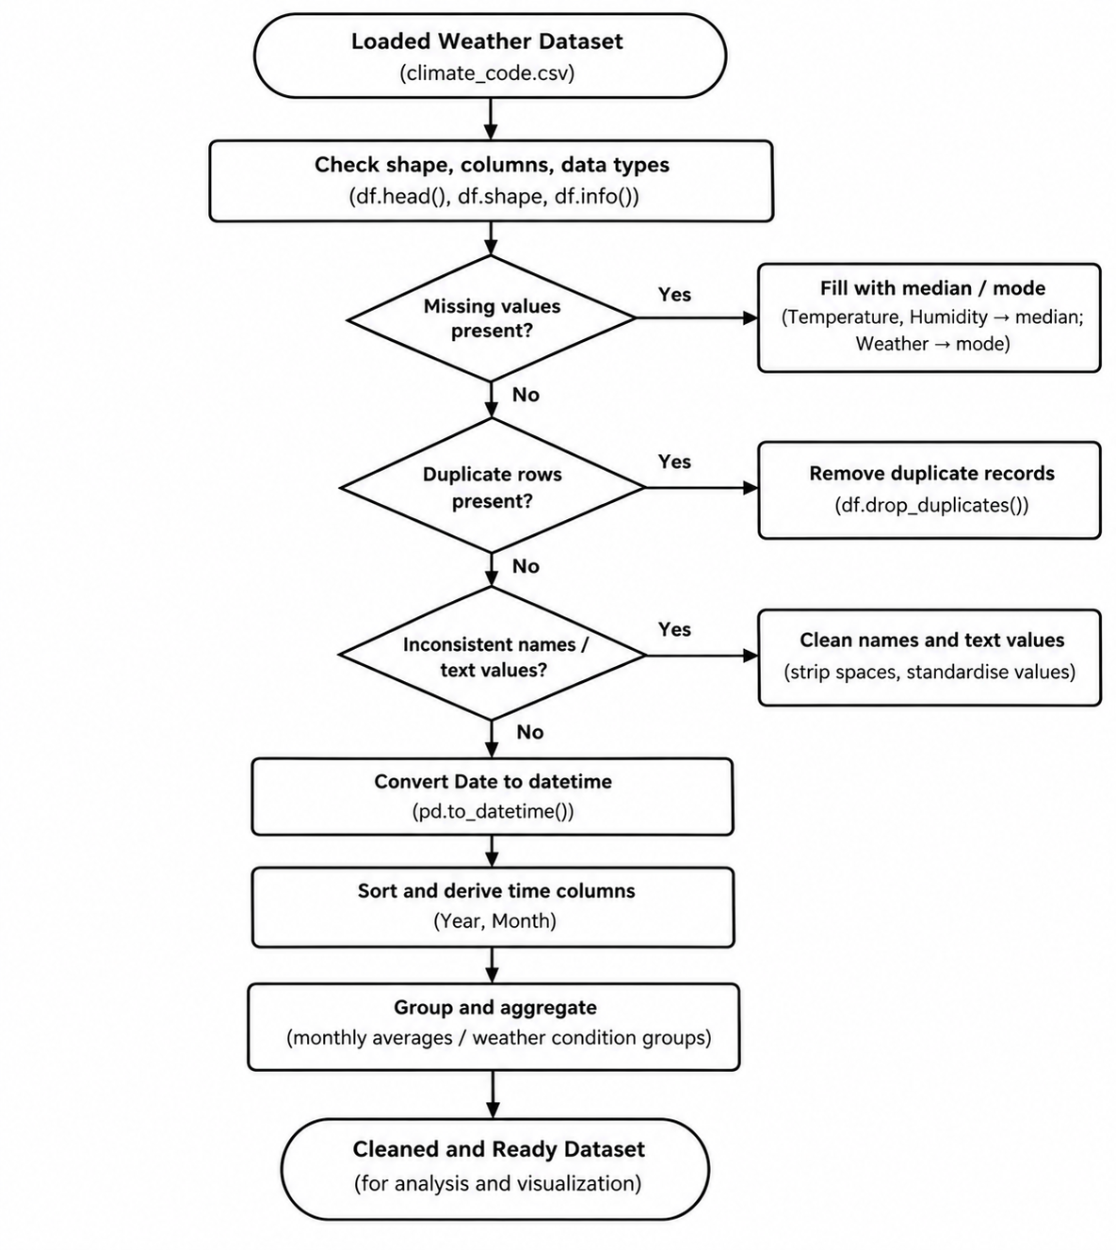

Fig 3.1: Data Cleaning Decision Flowchart

3.7 Data Transformation and Aggregation
After cleaning, the data is transformed into forms that are convenient for charts. The common transformations are described below.
3.7.1 Sorting and Selecting
# Sort weather records by date
df = df.sort_values("Date")
# Select only the required columns
subset = df[["Date", "Temperature", "Humidity", "Weather"]]
# Display the first 10 records
print(subset.head(10))

3.7.2 Grouping
# Calculate average temperature for each weather condition
weather_mean = df.groupby("Weather")["Temperature"].mean()
# Calculate average humidity for each weather condition
humidity_mean = df.groupby("Weather")["Humidity"].mean()
# Calculate monthly average temperature and humidity
monthly_avg = df.groupby(df["Date"].dt.month)[ ["Temperature", "Humidity"] ].mean() print(weather_mean) print(humidity_mean) print(monthly_avg)

3.7.3 Creating Derived Columns
# Convert temperature from Celsius to Fahrenheit
df["Temperature_F"] = df["Temperature"] * 9/5 + 32

# Extract year and month from the Date column
df["Year"] = df["Date"].dt.year
df["Month"] = df["Date"].dt.month

print(df.head())

Derived columns provide additional information for analysis. The Temperature_F column converts temperature from Celsius to Fahrenheit, while the Year and Month columns support time-based grouping and comparison. These transformations make the weather dataset more useful for creating charts and identifying trends over time.

3.8 Validation After Preprocessing
Check | Expected result | Command
Missing values | 0 in all cleaned columns | df.isnull().sum()
Duplicate rows | 0 | df.duplicated().sum()
Date column type | datetime64 | df["Date"].dtype
Chronological order | Dates increasing | df["Date"].is_monotonic_increasing
Negative temperature values | Checked and verified against the dataset | (df[“Temperature”] < 0).sum()
Invalid dates | 0 invalid dates remaining | df["Date"].isnull().sum()
Humidity range | Values between 0 and 100% | df[“humidity”].between(0,100).all()
Dataset structure | Expected columns and data types | Df.info()

Chapter 4: System Design and Methodology

4.1 Proposed Methodology
- Collect or obtain the weather dataset (climate_code.csv).
- Load the dataset into a Pandas DataFrame.
- Inspect rows, columns, data types, missing values, and duplicate records.
- Clean and transform the weather dataset.
- Perform exploratory and statistical analysis of temperature, humidity, and weather conditions.
- Perform weather-condition-wise analysis to compare average temperature and humidity.
- Perform time-series analysis using the Date column to identify trends over time.
- Generate visualizations using Matplotlib.
- Interpret the visualizations and organize the results into the final project report.
4.1.1 Explanation of the Methodology
The methodology follows the standard data analysis pipeline. In the first phase, the weather dataset is obtained and loaded into Python using Pandas. In the second phase, the dataset is inspected and cleaned by handling missing values, removing duplicate records, correcting data types, and processing dates. In the third phase, the cleaned data is summarized using statistical measures, grouping, aggregation, and time-series analysis. In the final phase, the results are presented through charts and interpreted to identify temperature trends, humidity patterns, and the distribution of weather conditions. Each phase produces an output that becomes the input for the next phase, creating a systematic workflow.

Phase | Activities | Output
Data acquisition | Obtain and load the climate_code.csv dataset | CSV files
Data understanding | Obtain and load the climate_code.csv dataset | Obtain and load the climate_code.csv dataset
Data preparation | Obtain and load the climate_code.csv dataset | Cleaned DataFrame
Analysis | Obtain and load the climate_code.csv dataset | Summary tables
Visualisation | Generate temperature trends, temperature distribution, humidity trends, and weather-condition charts | Charts and graphs
Interpretation | Explain patterns | Conclusions

4.2 System Workflow / Architecture
The overall workflow of the Weather Data Analysis System can be represented as:
Raw Weather Dataset (climate_code.csv) → Data Loading → Data Inspection → Data Cleaning → Date Processing and Sorting → Exploratory Data Analysis → Statistical and Time-Series Analysis → Data Visualization → Project Report → Interpretation of Weather Patterns.

4.3 Flowchart
The project flowchart shows the complete workflow of the Weather Data Analysis System, starting from the input weather dataset and ending with visualization and interpretation. The flowchart includes data loading, inspection, cleaning, date processing, exploratory data analysis, statistical analysis, and visualization. Standard process, decision, and output symbols are used to represent each stage clearly.
The flowchart uses standard symbols: rounded rectangles for the start and end of the process, rectangles for processing steps, diamonds for decisions, and arrows to indicate the direction of flow. The flowchart is drawn in black and white so that it can be printed clearly in the project report.

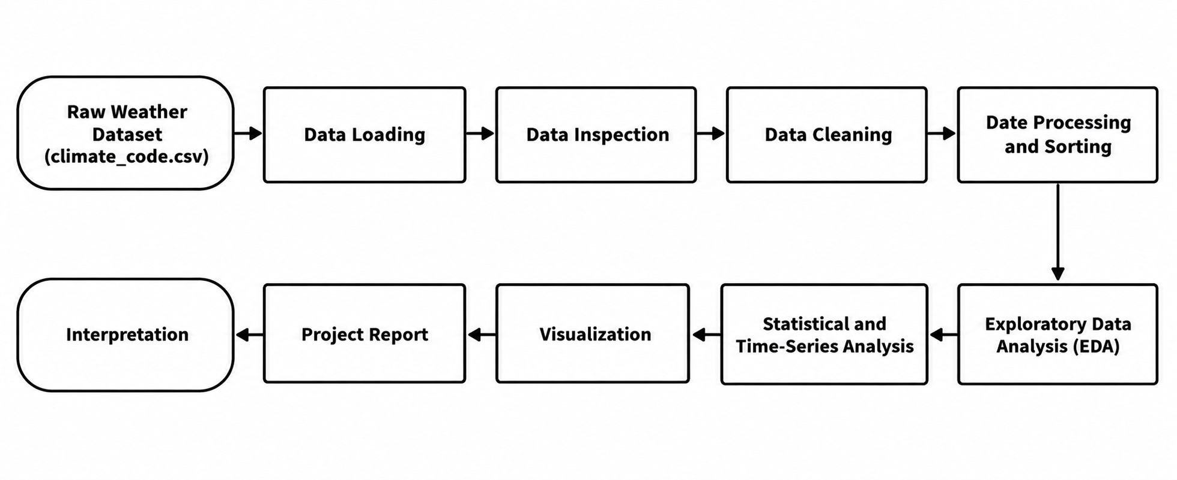
Fig 4.3: Project Workflow / System Architecture Flowchart
4.3.1 Description of the Blocks in the Flowchart
- Raw Weather Dataset: The climate_code.csv file containing Date, Temperature, Humidity, and Weather attributes.
- Data Loading: Loading the CSV file into a Pandas DataFrame using Python.
- Data Inspection: Checking the dataset shape, column names, data types, missing values, and duplicate records.
- Data Cleaning: Handling missing values, removing duplicate records, and correcting inconsistent text values.
- Date Processing and Sorting: Converting the Date column into datetime format, removing invalid dates, and arranging records chronologically.
- Exploratory Data Analysis: Examining the dataset using descriptive statistics and summary tables.
- Statistical and Time-Series Analysis: Calculating temperature and humidity statistics, comparing weather conditions, and analysing trends over time.
- Visualization: Creating line graphs, histograms, bar charts, and other relevant visualizations using Matplotlib.
- Project Report: Organizing the charts, statistical results, and analysis outputs into the final report.
- Interpretation: explaining what the visual patterns show.

4.4 Tools and Technologies Used
- Python – Primary programming language used for data processing, statistical analysis, and visualization.
- Pandas – Used for loading the weather dataset, handling missing values, removing duplicates, grouping, aggregation, and data analysis.
- NumPy – Used for numerical operations and calculations during data analysis.
- Matplotlib – Used to create line graphs, histograms, bar charts, and other visualizations to represent weather patterns.
- Google Colab / Jupyter Notebook – Development and execution environment used to write and run Python code.
- CSV (Comma-Separated Values) – File format used to store the weather dataset (climate_code.csv).

4.5 Analysis Methods Used
The Weather Data Analysis System uses descriptive statistics, grouping and aggregation, comparative analysis, time-series analysis, and graphical visualization. These methods help identify temperature changes over time, compare weather conditions, summarize numerical measurements, and communicate weather patterns effectively.
4.5.1 Descriptive Statistics
Descriptive statistics summarise weather data using measures such as count, mean, minimum, maximum, standard deviation, and quartiles. In Pandas, these measures can be obtained using the describe() function. This helps understand the distribution of temperature and humidity values.
4.5.2 Grouping and Aggregation
The groupby() function divides the dataset into groups based on a specific column, such as Weather, and applies functions such as mean(), min(), and max() to each group. This helps compare average temperature and humidity across different weather conditions.
4.5.3 Time-Series Analysis
Since the dataset contains a Date column, temperature and humidity values can be plotted over time to observe changes, peaks, and variations. Grouping observations by month and calculating monthly averages helps identify longer-term patterns in the available data.
4.5.4 Data Visualisation
Data visualization converts numerical results into charts so that patterns can be identified easily. Each chart type is selected according to the analysis question. Line charts show trends, bar graphs compare categories, histograms display distributions, and scatter plots show relationships between two numerical variables.
Question | Chart type
How did temperature and humidity change over time? | Line chart
Which weather condition occures most frequently? | Bar graph
How are temperature values distributed? | Histogram
How do temperature and humidty related to each other? | Scatter plot
How does average temperature vary across weather conditions? | bar chart
How do temperature and humidity change together over time? | Overlaid line chart

4.6 Software and Hardware Requirements
Requirement | Details
Programming language | Python 3.x
Libraries | Pandas, Matplotlib (NumPy as dependency)
Environment | Google Colab or Jupyter Notebook
Data source | Weather dataset(climate_code.csv)
Operating system | Windows / Linux / macOS
Hardware | Computer with 4 GB RAM or more and an internet connection

4.7 Modular Design
The Weather Data Analysis System is divided into five modules, each with a specific responsibility. The data module loads the weather dataset, the cleaning module prepares the data, the analysis module performs statistical calculations, the visualization module generates charts, and the report module organizes the results. This modular design makes the project easier to understand, maintain, and modify.

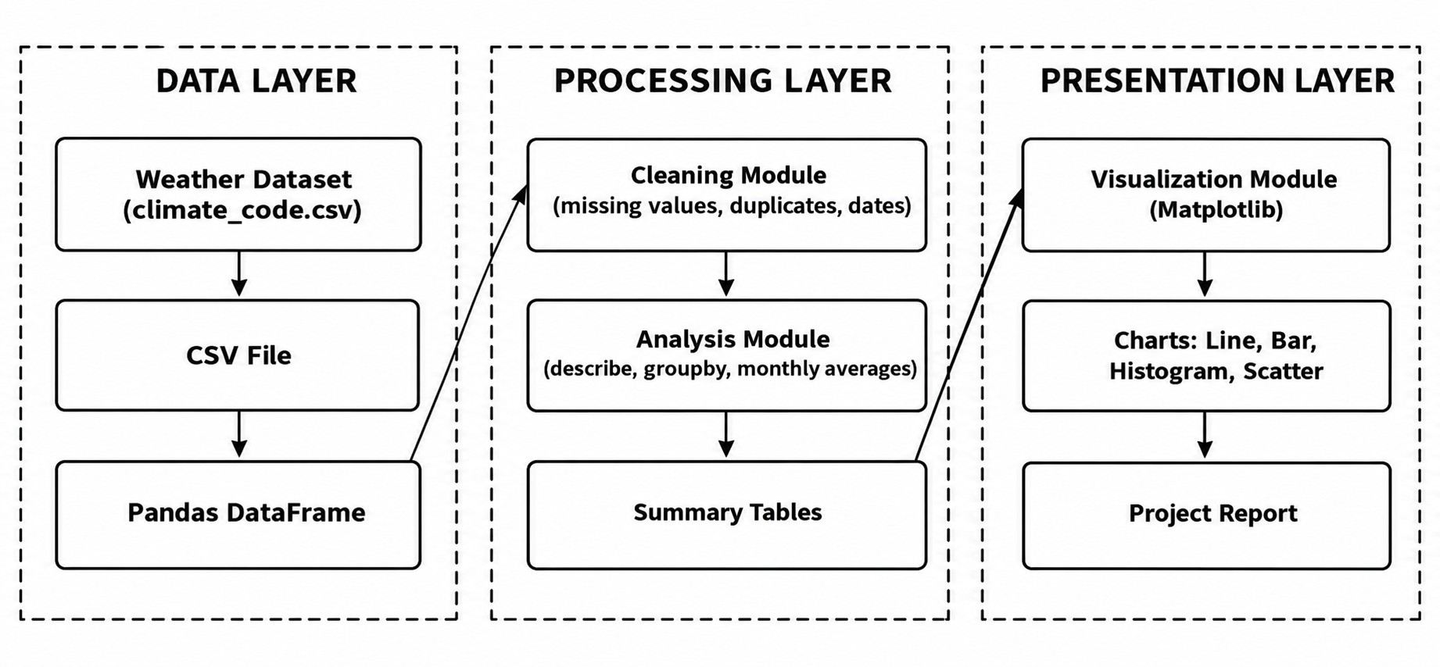
Fig 4.4: Modular Design of the Weather Data Analysis System
Module | Responsibility | Main functions used
Data module | Read dataset files | pd.read_csv()
Cleaning module | Fix missing, duplicate and inconsistent data | fillna(), dropna(), drop_duplicates(), to_datetime()
Analysis module | Statistics and group  weather conditions, and analyse monthly trends | describe(), groupby(),  mean(), min(), max()
Visualisation module | Draw the charts | plot(), bar(), pie(), scatter()
Dashboard module | Arrange charts together | subplots(), figure layout

4.8 Dashboard Layout Design
The dashboard arranges the main charts in a single view so that a reader can understand the situation at a glance. The layout used has four panels: the top-left panel shows the trend of new cases over time, the top-right panel shows the trend of deaths, the bottom-left panel compares the top ten countries and the bottom-right panel compares the WHO regions. All panels use black, white and gray tones and a thin black border so that the dashboard prints clearly. The complete dashboard view is shown in Section 6.7.

Chapter 5: Implementation

5.1 Development Environment
The implementation of the Weather Data Analysis System is carried out using Python in an environment such as Google Colab or Jupyter Notebook. These environments support Python code execution, weather dataset loading, DataFrame inspection, data cleaning, statistical analysis, and visualization. The project uses Pandas and NumPy for data processing and Matplotlib for generating charts.
5.1.1 Steps to Set Up the Environment
- Open Google Colab (colab.research.google.com) and sign in with a Google account, or open Jupyter Notebook on the local computer.
- Create a new notebook and give it a suitable name such as weather_data_analysis.ipynb.
- Upload the weather dataset file, climate_code.csv, to notebook session.
- Import the required libraries in the first code cell.
pandas as pd
import numpy as np
import matplotlib.pyplot as plt

plt.rcParams["figure.figsize"] = (10, 5)
plt.style.use("grayscale") # Blue-and-white charts

The grayscale style is used so that every chart is produced in black,blue, white and gray tones, which makes the document suitable for black-and-white printing.

5.2 Dataset Loading and Exploration
The dataset is loaded using Pandas. After loading, sample records are displayed, and the DataFrame structure is inspected. The number of records, column names, data types, missing values, and summary statistics are examined before performing further analysis.
5.2.1 Step-by-Step Implementation of Loading
Step 1: Import the required libraries.
Step 2: Read the weather CSV file into a Pandas DataFrame.
Step 3: Display the first five rows of the dataset.
Step 4: Display the dataset structure using info().
Step 5: Display summary statistics using describe().

import pandas as pd
import numpy as np
import matplotlib.pyplot as plt

# Read the weather dataset
df = pd.read_csv("climate_code.csv")

# Display the first five rows
print("First five records:")
print(df.head())

# Display dataset structure
print("\nDataset Information:")
df.info()

# Display summary statistics
print("\nSummary Statistics:")
print(df.describe())

# Display dataset shape
print("\nDataset Shape:", df.shape)

# Check missing values
print("\nMissing Values:")
print(df.isnull().sum())

5.3 Preprocessing Implementation
Preprocessing prepares the weather dataset for analysis by handling missing values, removing duplicates, converting dates, and sorting records chronologically.
5.3.1 Step-by-Step Implementation of Preprocessing
The implementation follows four steps: handle missing values, remove duplicates, convert dates, and verify the cleaned data.
# Step 1: Handle missing values
df["Temperature"] = df["Temperature"].fillna(df["Temperature"].median())
df["Humidity"] = df["Humidity"].fillna(df["Humidity"].median())
df["Weather"] = df["Weather"].fillna(df["Weather"].mode()[0])

# Step 2: Remove duplicates
df = df.drop_duplicates()

# Step 3: Convert and sort dates
df["Date"] = pd.to_datetime(df["Date"], errors="coerce")
df = df.dropna(subset=["Date"]).sort_values("Date")

# Step 4: Verify cleaning
print(df.isnull().sum())
print("Duplicates:", df.duplicated().sum())

5.4 Exploratory Data Analysis
Exploratory Data Analysis is used to understand the distribution and relationships within the dataset. GroupBy operations can summarize temperature and humidity according to weather conditions or months. Descriptive statistics provide measures such as count, mean, minimum, maximum, and standard deviation for numerical columns.
5.4.1 Step-by-Step Implementation of EDA
# Average temperature and humidity by weather condition
weather_summary = df.groupby("Weather")[
["Temperature", "Humidity"]
].mean()
print(weather_summary)

# Monthly average temperature and humidity
monthly = df.groupby(df["Date"].dt.month)[
["Temperature", "Humidity"]
].mean()
print(monthly)

# Overall descriptive statistics
print(df[["Temperature", "Humidity"]].describe())

The first block groups the data by weather condition and calculates average temperature and humidity. The second block calculates monthly averages to help identify changes over time. The third block displays descriptive statistics, providing an overview of the numerical weather attributes.

5.5 Time-Series and Geographic Analysis
Time-series analysis organizes weather data chronologically to study changes in temperature and humidity across different dates. Monthly analysis groups weather observations by month to calculate average temperature and humidity. These analyses provide the basis for understanding weather trends and creating comparative charts.
5.5.1 Step-by-Step Implementation of Time-Series Analysis
# Daily temperature trend
plt.plot(df["Date"], df["Temperature"], color="black")

plt.title("Temperature Over Time")
plt.xlabel("Date")
plt.ylabel("Temperature (°C)")
plt.xticks(rotation=45)
plt.tight_layout()
plt.show()
# Monthly averages
monthly = df.groupby(df["Date"].dt.month)[
["Temperature", "Humidity"]
].mean()

print(monthly)

5.6 Important Code Explanation
Important implementation steps in the Weather Data Analysis System include importing Pandas and Matplotlib, loading the weather dataset, checking DataFrame information, handling missing values, removing duplicate records, converting dates, grouping data, calculating statistical measures, and plotting weather trends. The final appendix should contain the exact source code used in the project.
Code element | Explanation
import pandas as pd | Loads the Pandas library for data handling
pd.read_csv() | Reads a CSV file into a DataFrame
df.isnull().sum() | Counts missing values column-wise
df.drop_duplicates() | Removes repeated rows
pd.to_datetime() | Converts text dates to datetime type
df.head() | Displays the first 5 rows of the dataset
df.info() | Displays column names,datatypes and non-null counts
df.[“Temperature”]*9/5 + 32 | Converts temperature from celsisus to fahrenheit
plt.bar() / plt.plot() / plt.hist()/plt.scatter() | Draws bar, line and histogram and scatter plot
plt.show()/plt.title() | Displays the chart and adds a title to a graph

5.7 Testing and Validation
The results of the analysis were tested to make sure that the code produced correct outputs. Some of the tests performed are listed below.
Test | Method | Result expected
File loads correctly | Check df.shape and df.head() | Rows and columns as in the CSV file
No missing values remain | df.isnull().sum().sum() | 0
Duplicate records are removed | Check df.duplicated().sum() | 0 duplicate rows remain.
Date conversion is correct | Check df["Date"].dtype | Date column is in datetime format.
Date order is correct | Check that the dates increase | True
Charts have labels | Visually check title, axes, legend | All present
Temperature conversion is correct |  | Fahrenheit values match the conversion formula
  Verify Temperature_F = Temperature * 9/5 + 32

5.8 Common Errors and Their Solutions
Error | Cause | Solution
FileNotFoundError | CSV file is not in the given path or was not uploaded to Colab | Upload the file or give the correct path
KeyError: 'Temperature' | Column name is spelled differently or has extra spaces | Print df.columns and strip spaces
UnicodeDecodeError | Different file encoding | Use pd.read_csv(file, encoding="latin1")
ValueError in to_datetime | Date text is not in the expected format | Give format="%Y-%m-%d" or errors="coerce"
Empty or unreadable chart | Data still contains text or missing values | Convert types and re-check cleaning
Overlapping axis labels | Long country names | Use plt.xticks(rotation=45)

Chapter 6: Data Visualization and Results

6.1 Line Chart
A line chart is used to represent Temperature Trend Over Time. The graph shows temperature fluctuations from 2023 to 2026, with recurring seasonal rises and falls. Temperatures mostly range from 15°C to 38°C, with a few peaks above 40°C.
plt.figure(figsize=(12,7))
plt.plot(df["Date"], df["Tempeature"], marker="o", linewidth=1)
plt.title("Temperature Trend Over Time")
plt.xlabel("Date"); plt.ylabel("Temperature (c)")
plt.grid(True, linestyle="--", alpha=0.5)
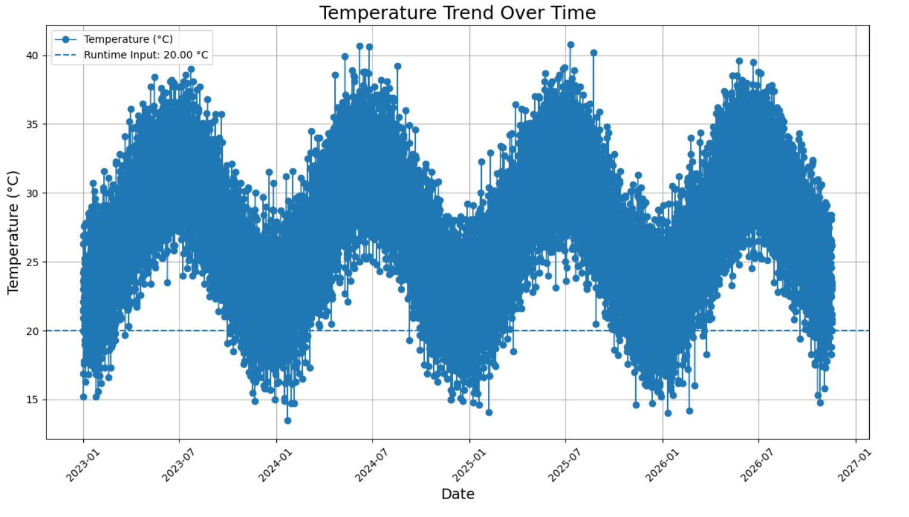
plt.show()

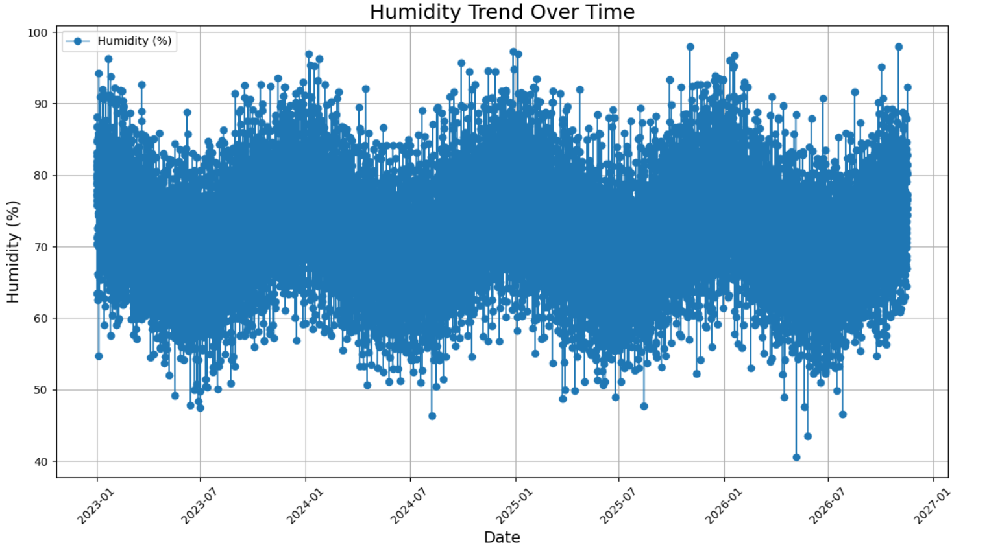
Fig 6.1(a): Temperature Trend Over Time (Line Chart)
Fig 6.1(b): Histogram Trend Over Time (Line Chart)
Interpretation of the Line Charts
1. Temperature Trend: Temperatures fluctuate seasonally from 2023 to 2026, mostly ranging between 15°C and 38°C, with a few peaks above 40°C.
2. Humidity Trend: Humidity varies over time, generally ranging between 50% and 90%, with occasional peaks near 98% and lows around 40%.

6.2 Bar Graph
The Weather Condition Frequency bar graph identifies the most and least common weather conditions, while the Average Temperature by Weather Condition graph compares average temperatures across conditions.
weather_counts = df["Weather"].value_counts()

plt.figure(figsize=(10, 6))
plt.bar(weather_counts.index,
weather_counts.values)
plt.title("Weather condition frequency")
plt.xlabel("weather condition"); plt.ylabel("number of records")
plt.show()

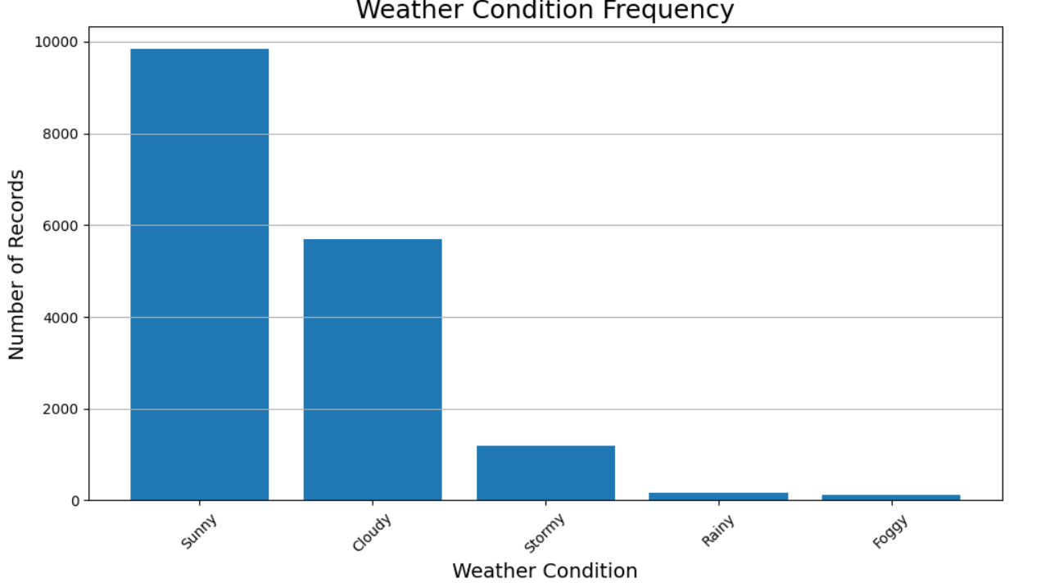
Fig 6.2(a): Weather Condition Frequency (Bar Graph)

Fig 6.2(b): Average Temperature by Weather Condition (Bar Graph)

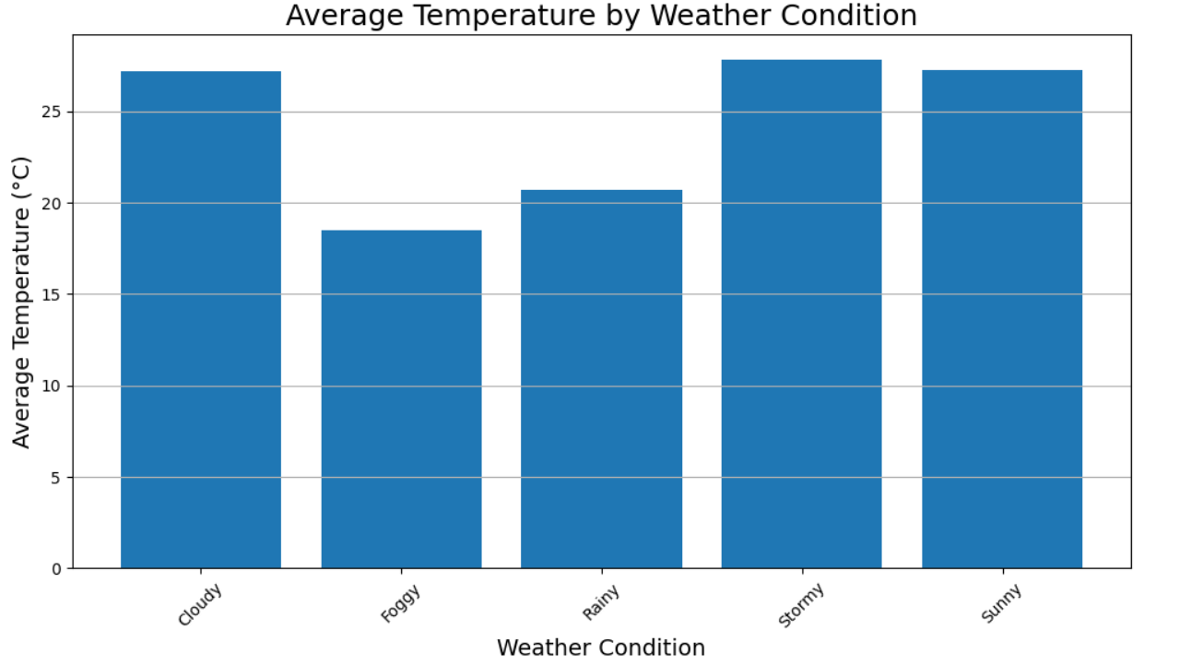

Interpretation of the Bar Graphs
1. Weather Condition Frequency: This bar graph compares the number of records for each weather condition and identifies the most common condition, which is Sunny.
2. Average Temperature by Weather Condition: This bar graph compares average temperatures across weather conditions, showing Stormy as the highest and Foggy as the lowest.

6.3 Histogram
This is a Histogram titled Temperature Distribution. It shows the frequency distribution of temperatures, while the dashed vertical line represents the runtime input temperature of 20°C.
plt.figure(figsize=(10, 6))
plt.hist(df["Temperature"],
bins=10,
edgecolor="black")
plt.title("Temperature Distribution")
plt.show()

The pie chart shows each WHO region as a slice of the total confirmed cases; black outlines and gray shading are used so that the slices remain distinguishable in a black-and-white print.
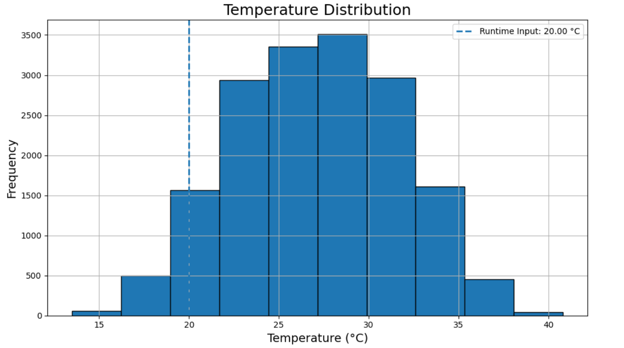
Fig 6.3: Temperature disturbition (Histogram)

Interpretation of the Histogram
The histogram shows that most temperatures fall between 22°C and 32°C, with the highest frequency around 27°C–30°C. The dashed line indicates the runtime input temperature of 20°C.

6.4 Scatter Plot
The scatter plot represents the relationship between temperature (°C) and humidity (%).The X-axis shows temperature, while the Y-axis shows humidity.Each dot represents one weather observation in the dataset.
plt.figure(figsize=(10,6))
plt.title("Temperature vs Humidity")
plt.xlabel("Temperature (c)")
plt.ylabel("Humidity")
plt.show()

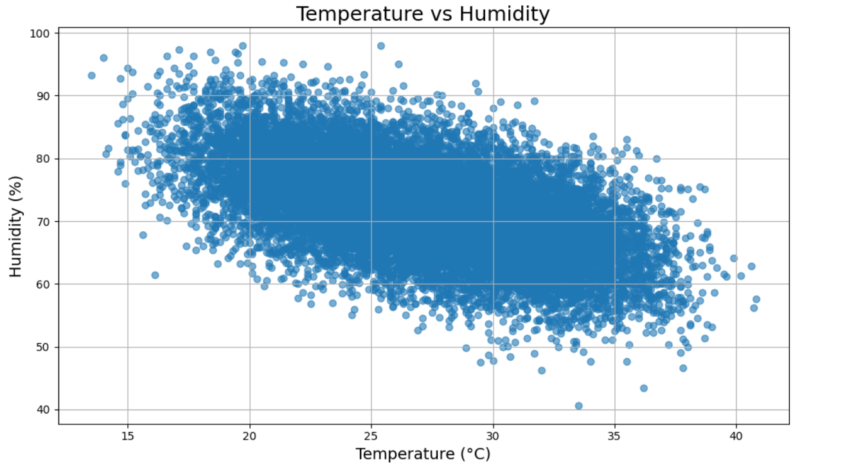
Fig 6.4: Temperature vs humidity(scatter plot)

Interpretation of the scatter Plot
The graph shows a general negative relationship between temperature and humidity.Humidity tends to decrease as temperature increases.However, the scattered points show that humidity also varies at similar temperatures.

6.5 Line graph
The line chart represents the monthly average temperature from January to December, with months on the X-axis and average temperature (°C) on the Y-axis. The connected points show how temperature changes throughout the year.

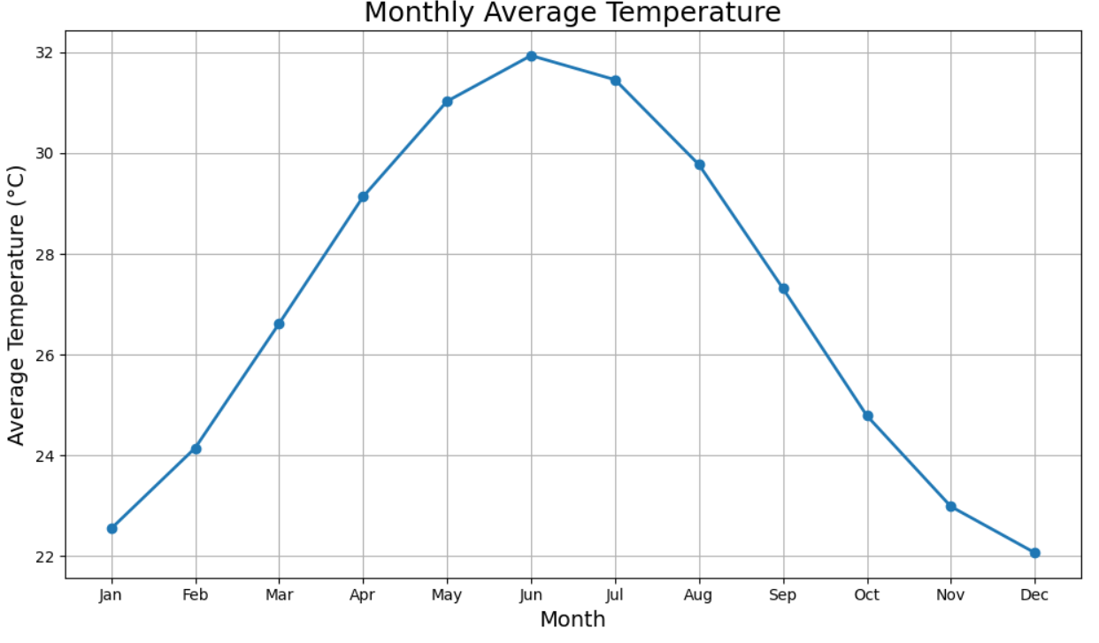
Fig 6.5: Monthly avarage temperature(line graph)

Interpretation of the line graph
The average temperature increases from January and reaches its highest point in June at approximately 32°C, then decreases gradually toward December, which has the lowest average temperature of around 22°C.

6.6 Interpretation of Visualizations
The temperature and humidity line charts show variations over time. The bar graphs compare weather frequencies and average temperatures. The histogram displays temperature distribution, while the scatter plot shows the relationship between temperature and humidity. Overall, the visualizations help identify weather patterns and trends.
6.6.1 Summary of Visualisations
Figure | Chart type | Main observation
6.1(a) | Line chart | Temperature fluctuates over time with seasonal variations.
6.1(b) | Line chart | Humidity levels vary significantly across different dates.
6.2(a) | Bar graph | Sunny weather occurs most frequently in dataset.
6.2(b) | Bar graph | Stormy conditions show the highest average temperature.
6.3 | Histogram | Most temperatures fall between 22°C and 32°C
6.4 | Scatter plot | Temperature generally increases as humidity decreases.
6.5 | Line chart | Temperature peaks in June and decreases toward December.

6.7 Dashboard View
The seven main charts are combined into 3 dashboard view. This gives the reader a summary of the time trend and the geographic comparison on one page.
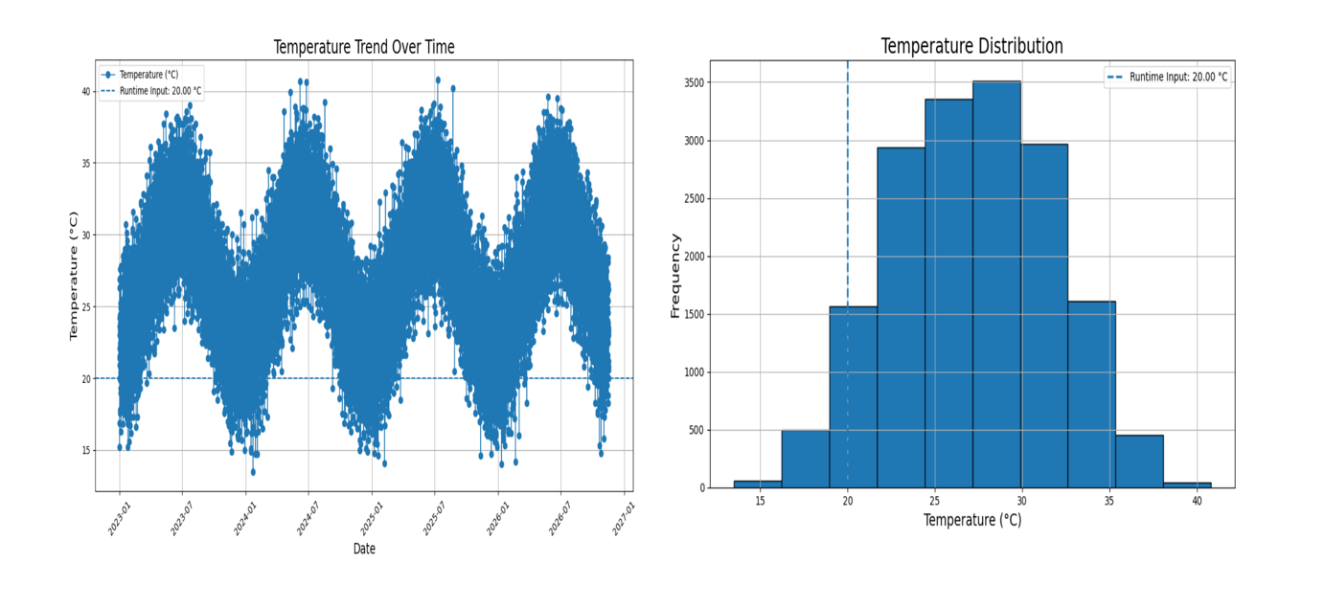

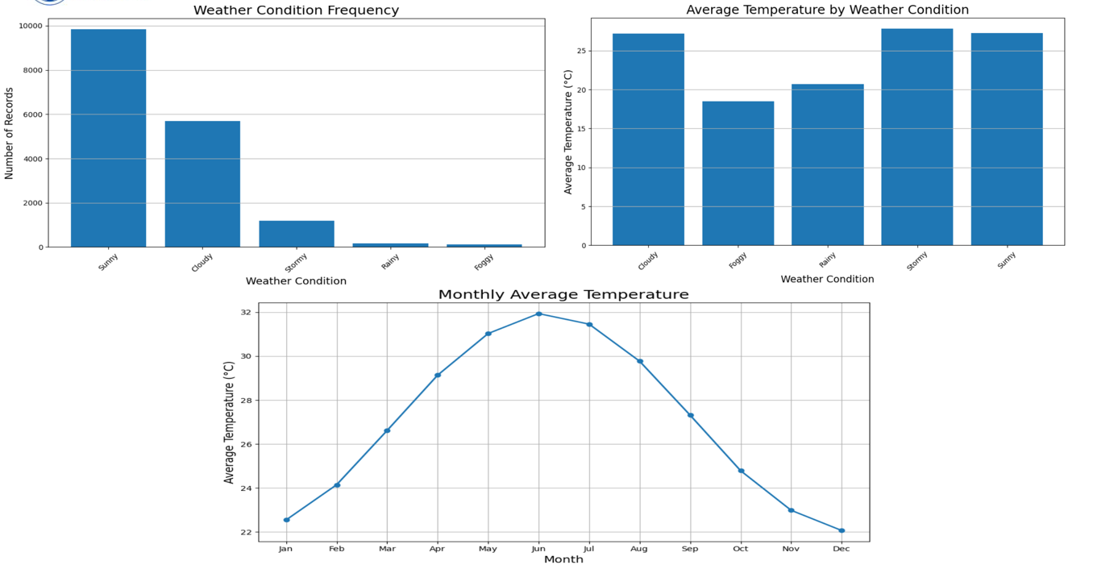
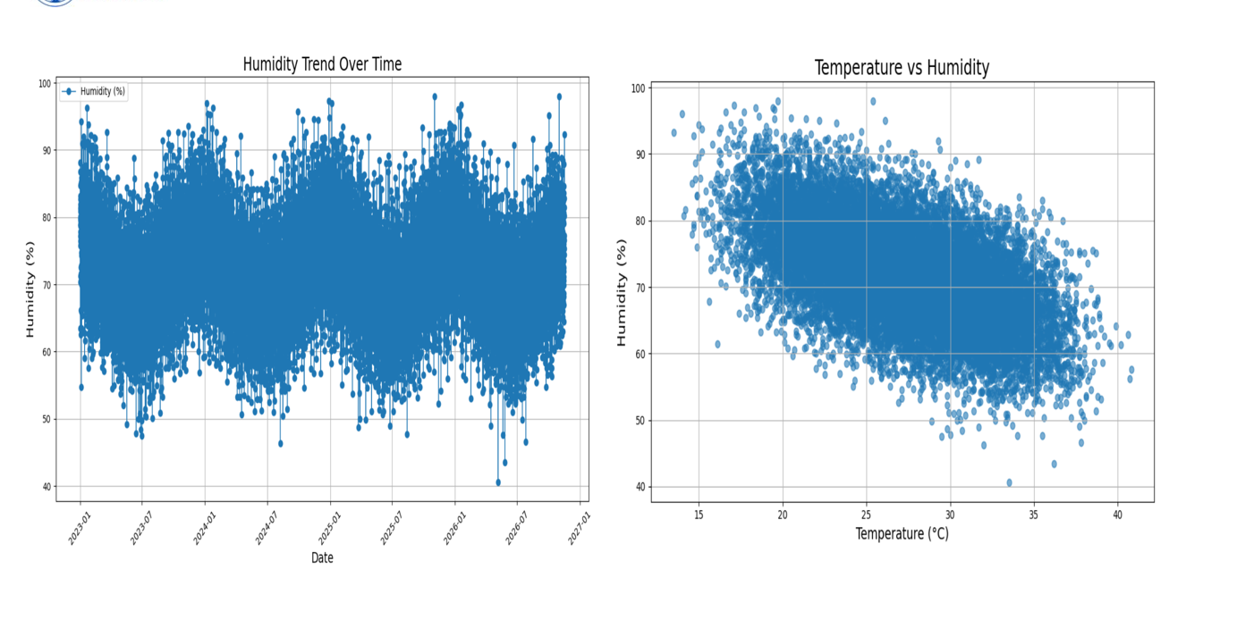

Fig 6.7: Weather data dashboard (combined view)

6.8 Preparing Charts for Black-and-White Printing
Colour may be lost when charts are printed in black and white. To ensure that all graphs in the Weather Data Analysis System remain clear and readable, black, white, and gray shades are used. Different line styles and bar patterns help distinguish the data without relying only on colours.

plt.style.use("grayscale")
# Line chart with different line styles
plt.plot(df["Date"], df["Temperature"],
color="black", linestyle="-",
label="Temperature")

plt.plot(df["Date"], df["Humidity"],
color="black", linestyle="--",
label="Humidity")
plt.legend()
plt.show()
# Bar chart with hatch patterns
plt.bar(labels, values,
color="white",
edgecolor="black",
hatch="//")
plt.show()

Technique | Purpose
plt.style.use("grayscale") | Converts the default colour cycle to gray shades
linestyle | Distinguishes temperature and humidity lines using different styles.
hatch | Separates bars using pattern fills
edgecolor="black" | Keeps the boundary of every bar clear
Black text and axes | Ensures readable labels when printed

Chapter 7: Analysis of Results

7.1 Analysis Approach
The analysis combines descriptive statistics, grouped summaries, time-series analysis, and data visualization. The purpose is to understand temperature, humidity, and weather conditions from the cleaned dataset and identify observable weather patterns and trends.

7.2 Observed Patterns
The patterns described below are taken directly from the graphs generated in Chapter 6.
7.2.1 Pattern 1: Temperature Variations Over Time
The temperature line chart shows fluctuations over time, with temperatures generally ranging between 15°C and 38°C and some peaks above 40°C. These variations indicate changes in temperature across different dates and periods.
7.2.2 Pattern 2: Humidity Changes Over Time
The humidity line chart shows considerable variation, with humidity levels generally ranging between 50% and 90%. Some values approach 98%, while others fall to around 40%, indicating changes in atmospheric moisture over time.
7.2.3 Pattern 3: Differences in Weather Conditions
The weather frequency bar graph shows that Sunny is the most frequently occurring weather condition in the dataset. The graph helps identify the most common weather conditions and compare their frequencies.
7.2.4 Pattern 4: Average Temperature Across Weather Conditions
The average temperature bar graph shows that Stormy conditions have the highest average temperature, while Foggy conditions have the lowest. This comparison highlights differences in average temperature among weather categories.
7.2.5 Pattern 5: Temperature Distribution
The temperature distribution histogram shows that most recorded temperatures fall between 22°C and 32°C, with a concentration around 27°C to 30°C. This helps identify the most common temperature range in the dataset.
7.2.6 Pattern 6: Relationship Between Temperature and Humidity
The scatter plot indicates a general negative relationship between temperature and humidity. Humidity tends to decrease as temperature increases, although the points show some variation.
7.2.7 Pattern 7: Monthly Average Temperature Changes
The monthly average temperature graph shows an increase from January toward June, when the average reaches approximately 32°C. After June, the average temperature generally decreases toward December, reaching around 22°C.
Pattern | Chart used | Type of analysis
 | Temperature line chart (Fig. 6.1(a)) | Time-series
  Temperature variations over time
Humidity changes over time | Humidity line chart (Fig. 6.1(b)) | Time-series comparison
Most frequent weather conditions | Weather frequency bar graph (Fig. 6.2(a)) | Frequency analysis
Average temperature by weather condition | Average temperature bar graph (Fig. 6.2(b)) | Comparative analysis
Distribution of temperatures
  Temperature histogram (Fig. 6.3)
  Distribution analysis
Temperature and humidity relationship |  | Relationship analysis
  Scatter plot (Fig. 6.4)
Monthly average temperature changes | Monthly average temperature line chart (Fig. 6.5) | Monthly trend analysis

7.3 Result Interpretation
The results are interpreted by combining numerical summaries with the corresponding visualizations. For each chart, the variable represented, comparison made, visible pattern, and limitation are considered to understand the weather data.
Chart | Variable | Comparison | Visible pattern
Temperature line chart | Temperature | Over dates | Temperature fluctuates over time, with some peaks above 40°C.
Humidity line chart | Humidity | Over dates | Humidity varies considerably, with values ranging approximately from 40% to 98%.
Weather frequency bar graph | Weather conditions | Between weather categories
  Sunny is the most frequently occurring weather condition.
Average temperature bar graph |  | Between weather categories
  Average temperature
  Stormy has the highest average temperature, while Foggy has the lowest.
Temperature histogram | Temperature | Across temperature ranges
  Most temperatures fall between 22°C and 32°C.
Temperature-humidity scatter plot | Temperature and humidity | Between two numerical variables | A general negative relationship is visible, with some variation.
Monthly average temperature line chart | Average temperature | Between months | Average temperature peaks in June and generally decreases toward December.

The interpretation describes the patterns visible in the dataset. These observations show variations in temperature, humidity, and weather conditions. The project identifies trends and relationships but does not establish the causes of these patterns.

7.4 Discussion
The Weather Data Analysis System demonstrates the importance of data preprocessing and visualization in understanding weather patterns. A cleaned and structured dataset makes statistical analysis more reliable, while graphs make temperature, humidity, and weather conditions easier to understand.
7.4.1 Importance of Data Cleaning
Converting the Date column into a proper date format helps arrange records chronologically. Removing duplicate records and handling missing values improves data quality and supports more reliable analysis. Therefore, preprocessing is an essential step in the project.
7.4.2 Importance of Choosing the Right Chart
Each chart helps answer a different question. Line charts show temperature and humidity changes over time, bar graphs compare weather conditions, histograms display temperature distribution, and scatter plots show the relationship between temperature and humidity. Choosing suitable charts makes patterns easier to identify.
7.4.3 Advantages of the Approach
- Uses free, open-source tools such as Python, Pandas, NumPy, and Matplotlib.
- Analyzes temperature, humidity, and weather conditions using a structured dataset.
- The workflow can be reused with updated weather data.
- Provides multiple charts for clear comparison and interpretation.
- Uses black-and-white charts suitable for printing.
- Helps identify trends and patterns through descriptive statistics and visualization.
7.4.4 Challenges Faced
- Understanding the meaning and data types of each dataset column.
- Handling missing values and duplicate records.
- Converting the Date column into the correct date format.
- Selecting suitable chart types for different analyses.
- Making graphs clear and readable in black-and-white printouts.
- Interpreting relationships between temperature and humidity without assuming causation.

7.5 Answers to the Analysis Questions
The questions set at the beginning of the project are answered below based on the generated charts and analysis.
Q1. How does temperature change over time?
The temperature line chart shows fluctuations over time, with temperatures generally ranging between 15°C and 38°C and some peaks above 40°C.
Q2. How does humidity change over time?
The humidity line chart shows variations in humidity levels, generally ranging between 50% and 90%, with some values near 40% and 98%.
Q3. Which weather condition occurs most frequently?
The weather frequency bar graph shows that Sunny is the most frequently occurring weather condition in the dataset.
Q4. Which weather condition has the highest average temperature?
The average temperature bar graph shows that Stormy has the highest average temperature, while Foggy has the lowest.
Q5. What is the most common temperature range?
The temperature distribution histogram shows that most recorded temperatures fall between 22°C and 32°C, with a concentration around 27°C to 30°C.
Q6. Is there a relationship between temperature and humidity?
The scatter plot shows a general negative relationship, where humidity tends to decrease as temperature increases, although some variations are present.
Q7. How does average temperature vary across months?
The monthly average temperature graph shows that temperature rises toward June, reaching approximately 32°C, and generally decreases toward December, reaching around 22°C.

7.6 Comparison of Chart Types Used
Chart | Strength | Limitation
Line chart | Shows change over time clearly | Too many lines make it confusing
Bar graph | Easy comparison between categories | Too many bars reduce readability
Histogram | Displays data distribution, frequency, spread, and skewness clearly. | Exact values are not shown, and results depend on bin size.
Scatter plot | Reveals relationships, correlations, trends, clusters, and outliers | Cannot prove causation, and overlapping points may hide patterns.

7.7 Limitations of the Interpretation
- The results depend on the accuracy and completeness of the collected weather data.
- Differences in geographical location and observation periods may affect comparisons.
- Charts show patterns and relationships but do not prove causes.
- The results are limited to the dataset used for analysis and may not represent all weather conditions.

Chapter 8: Output Screenshots

8.1 Dataset Screenshots
The following screenshots show the outputs obtained while loading and inspecting the weather dataset (climate_code.csv) using Python and Pandas in Google Colab. The dataset contains four main columns: Date, Temperature, Humidity, and Weather.
Screenshot | Description | Figure no.
Dataset upload / load output | Dataset file uploaded in Google Colab | Fig 8.1
Dataset shape and column names | Displays the number of rows, columns, and column names | Fig 8.2
df.head() | Displays first five rows of the dataset | Fig 8.3
df.info() | Data types and non-null counts | Fig 8.4
Statistical summary | Shows count,mean, standard deviation, minimum, maximum,and quartiles | Fig 8.5

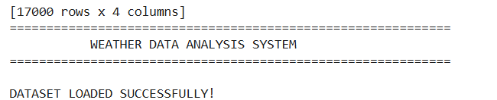

Fig 8.1: Weather dataset upload and load output (shape of the dataset)
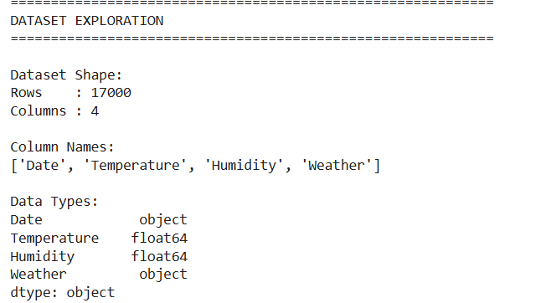
Fig 8.2: Column names, number of countries and date range
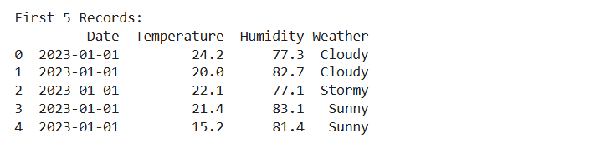

Fig 8.3: First five rows of the dataset - df.head()
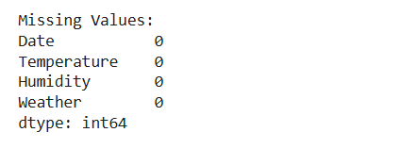

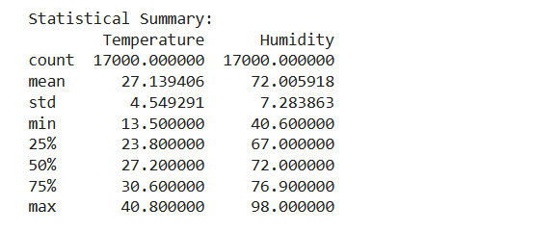
Fig 8.4: Data types and non-null counts - df.info()

Fig 8.5: Statistical summary of temperature and humidity

8.2 Preprocessing Outputs
The following screenshots present the outputs obtained during data preprocessing and cleaning. One duplicate record was removed, and no missing values were present before or after cleaning.

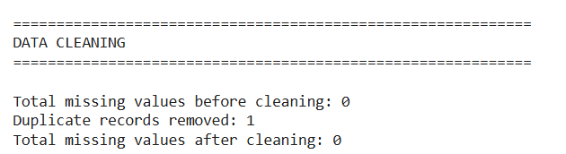
Screenshot | Description | Figure no.
df.isnull().sum() | Missing-value check | Fig 8.6
df.duplicated().sum() | Duplicate check | Fig 8.7
Date and numerical preprocessing | Date and numeric column preprocessing output | Fig 8.8
Cleaned DataFrame | DataFrame after preprocessing | Fig 8.9
Saved cleaned dataset | Confirmation msg for saving cleaned dataset | Fig 8.10

Fig 8.6: Missing values before preprocessing - df.isnull().sum()

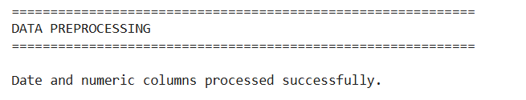
Fig 8.7: Duplicate records check - df.duplicated().sum()

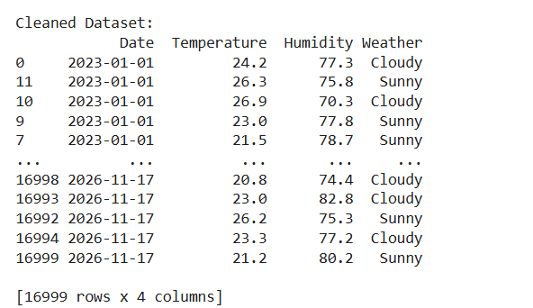
Fig 8.8: Date and numeric column preprocessing output

Fig 8.9: Cleaned weather dataset containing 16,999 rowsStatistical Analysis

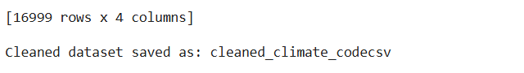
Fig 8. 10: Confirmation of the cleaned dataset being saved

8.3 Statistical Analysis Outputs
This section presents the numerical results obtained from temperature, humidity, and weather-condition analysis.
Screenshot | Description | Figure no.
Temperature analysis |  | Fig 8.11
  Displays minimum, maximum, and average temperature
Humidity analysis | Displays minimum, maximum, and average humidity | Fig 8.12
Weather condition analysis | Displays the frequency of each weather condition and the most common condition | Fig 8.13

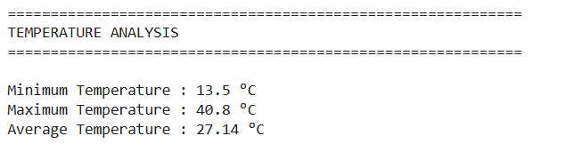
Fig 8.11: Temperature analysis results
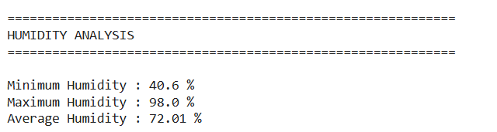
Fig 8.12: Humidity analysis results
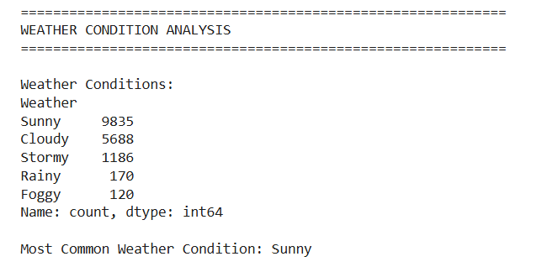
Fig 8.13:Weather condition frequency and most common weathe condition

8.4 visualization Outputs
The following figures are the graphs generated by the project code.
Screenshot | Description | Figure no.
Line chart |  | Fig 8.14
  Temperature changes over time
Line chart | Humidity changes over time | Fig 8.15
Bar graph |  | Fig 8.16
  Frequency of different weather conditions
Bar graph | Average temperature by weather condition | Fig 8.17
Histogram | Distribution of temperature values | Fig 8.18
Scatter plot |  | Fig 8.19
  Relationship between temperature and humidity
Line chart | Monthly average temperature | Fig 8.20
Fig 8.14: Temperature trend over time
Fig 8.15: Humidity trend over time

Fig 8.16: Frequency of different weather conditions
Fig 8.17: Average temperature by weather condition
Fig 8.18: Distribution of temperature values
Fig 8.19: Temperature vs humidity

Fig 8.20: monthly average temperature

8.5 Dashboard Outputs
The final combined dashboard used for the project presentation is shown below.

Fig 8.21: Humidity trend over time and Temperature vs humidit

Fig 8.22: Temperature trend over time and Distribution of temperature values

Fig 8.23: Frequency of different weather conditions ,Average temperature by weather condition
and Monthly average temperature trend

8.6 Runtime Temperature Conversion Outputs
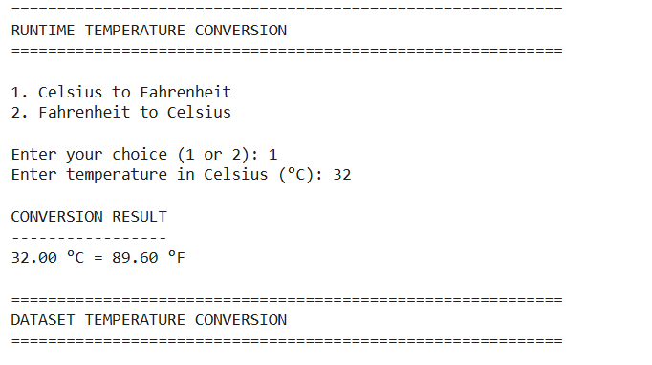
The project also includes an interactive temperature-conversion option that allows users to convert Celsius to Fahrenheit or Fahrenheit to Celsius.

Fig 8.24: Runtime temperature conversion menu and output

Chapter 9: Conclusion and Future Enhancements

9.1 Conclusion
The Weather Data Analysis System demonstrates how Python-based data analysis can transform raw weather records into structured and understandable information. The project uses a dataset containing 17,000 records with four attributes: Date, Temperature, Humidity, and Weather. It covers data loading, preprocessing, duplicate removal, statistical analysis, time-series analysis, and data visualization.
The analysis identified an average temperature of 27.14°C and average humidity of 72.01%. Sunny was the most frequently recorded weather condition, with 9,835 records. The generated charts help examine temperature trends, humidity variations, weather-condition frequencies, temperature distribution, and relationships between weather attributes. Overall, the project provides a simple and effective way to understand weather data using Python, Pandas, NumPy, and Matplotlib.

9.2 Limitations
- The quality of the analysis depends on the accuracy and completeness of the weather dataset.
- The project focuses on descriptive analysis and does not predict future weather conditions.
- The results are limited to the dates, temperature values, humidity values, and weather conditions available in the dataset.
- The visualizations identify patterns and relationships but do not establish their causes.
- Static charts require manual execution of the code when updated data needs to be analysed.
- The findings may not represent weather conditions in every geographical location.

9.3 Future Enhancements
- Integrate a reliable live weather API to retrieve updated weather information automatically.
- Develop an interactive dashboard using tools such as Streamlit or Plotly.
- Add filters for date ranges, temperature, humidity, and weather conditions.
- Include additional visualizations and statistical comparisons for more detailed analysis.
- Generate automated weather analysis reports at regular intervals.
- Extend the project with a validated weather prediction model as a separate module.
- Add location-based weather analysis to compare conditions across different cities or regions when suitable data is available.
9.3.1 Explanation of Future Enhancements
Integrating a live weather API would allow the system to retrieve updated weather information automatically. An interactive dashboard using Streamlit or Plotly could help users explore graphs and filter results by date and weather condition. Additional visualizations and automated report generation would make the analysis more flexible and efficient. In the future, a validated weather prediction model and location-based analysis could also be added to predict weather variables and compare weather conditions across different geographical areas.

9.4 Learning Outcomes
- Learned how to load and use a weather dataset using Python and Pandas.
- Learned to inspect and clean a dataset by removing duplicate records and checking missing values.
- Learned to process date values and perform time-series analysis.
- Learned to calculate statistical measures such as minimum, maximum, mean, and standard deviation.
- Learned to analyse temperature, humidity, and weather-condition frequencies.
- Learned to create and interpret line charts, bar graphs, histograms, and scatter plots using Matplotlib.
- Learned to prepare a structured project report with workflow diagrams, figures, and analysis results.

9.5 Final Remarks
The Weather Data Analysis System demonstrates how raw weather data can be transformed into meaningful information through a systematic data analysis process. The project strengthened the understanding of data loading, preprocessing, statistical analysis, and visualization. It also highlighted the importance of data quality, appropriate chart selection, and careful interpretation of results. Overall, the project provides practical experience in using Python-based tools to explore weather patterns and present analytical findings clearly.

9.6 Summary of Objectives and Outcomes
Objective | Outcome
Load and understand the weather dataset | Dataset  climate_code.csv dataset containing 17,000 rows and 4 columns was loaded using Pandas.
Inspect structure, missing and duplicate values | Checked with info(), isnull(), duplicated()
Clean and organise the dataset | Missing values handled, duplicates removed, dates converted
Perform temperature analysis | Calculated minimum temperature (13.5°C), maximum temperature (40.8°C), and average temperature (27.14°C).
Perform humidity analysis | Calculated minimum humidity (40.6%), maximum humidity (98%), and average humidity (72.01%).
Summary and grouped statistics | describe() and groupby(),  mean(), min(), and max()  used
Analyse weather-condition frequency | Identified Sunny as the most common weather condition, with 9,835 records
Perform time-series analysis | Analysed temperature and humidity variations over time using line charts.
Create visualisations using Matplotlib | Prepared line charts, bar graphs, a histogram, and a scatter plot for weather data analysis
Perform temperature conversion | Implemented a runtime option to convert Celsius to Fahrenheit and Fahrenheit to Celsius.
Present the analysis results | Organised statistical outputs and visualisations to explain weather patterns clearly.

10. References
- Python Software Foundation, Python Documentation, https://docs.python.org/3/
- Pandas Development Team, Pandas Documentation, https://pandas.pydata.org/docs/
- NumPy Developers, NumPy Documentation, https://numpy.org/doc/
- Matplotlib Development Team, Matplotlib Documentation, https://matplotlib.org/stable/
- Project Dataset, Weather Data (climate_code.csv), used for temperature, humidity, and weather-condition analysis.
- Project Development Environment, Google Colab, https://colab.research.google.com/
- W. McKinney, Python for Data Analysis: Data Wrangling with Pandas, NumPy, and Jupyter, O'Reilly Media.

11. Appendix – Source Code
The complete Python source code used for loading, cleaning, analysing and visualising the dataset is given below.
A. Import Libraries and Load Data
import pandas as pd
import numpy as np
import matplotlib.pyplot as plt
plt.style.use("grayscale")
plt.rcParams["figure.figsize"] = (10, 5)
from google.colab import files

uploaded = files.upload()
filename = next(iter(uploaded))

df = pd.read_csv(filename)

print("=" * 60)
print("WEATHER DATA ANALYSIS SYSTEM")
print("=" * 60)

print("\nDATASET LOADED SUCCESSFULLY!")
print("\nFirst 5 Records:")
print(df.head())

print("\nDataset Shape:")
print("Rows:", df.shape[0])
print("Columns:", df.shape[1])

print("\nColumn Names:")
print(df.columns.tolist())

print("\nData Types:")
print(df.dtypes)

print("\nMissing Values:")
print(df.isnull().sum())

print("\nStatistical Summary:")
print(df.describe())

B. Data Preprocessing
print("\nDATA PREPROCESSING")
print("\nMissing values before cleaning:")
print(df.isnull().sum())

# Convert Date column into datetime format
df["Date"] = pd.to_datetime(
df["Date"], errors="coerce"
)

# Convert numerical columns into numeric format
df["Temperature"] = pd.to_numeric(
df["Temperature"], errors="coerce"
)

df["Humidity"] = pd.to_numeric(
df["Humidity"], errors="coerce"
)

# Remove records with invalid dates
df = df.dropna(subset=["Date"])

# Handle missing numerical values using median
df["Temperature"] = df["Temperature"].fillna(
df["Temperature"].median()
)

df["Humidity"] = df["Humidity"].fillna(
df["Humidity"].median()
)

# Handle missing weather conditions using mode
df["Weather"] = df["Weather"].fillna(
df["Weather"].mode()[0]
)

# Remove duplicate records
duplicate_count = df.duplicated().sum()
print("\nDuplicate records removed:", duplicate_count)

df = df.drop_duplicates()

# Remove extra spaces from weather labels
df["Weather"] = df["Weather"].str.strip()

# Sort records by date
df = df.sort_values("Date").reset_index(drop=True)

print("\nMissing values after cleaning:")
print(df.isnull().sum())

print("\nCleaned Dataset:")
print(df.head())

print("\nCleaned Dataset Shape:", df.shape)

# Save cleaned dataset
df.to_csv("cleaned_climate_code.csv", index=False)

print("\nCleaned dataset saved successfully!")

C. Statistics
print("\n" + "=" * 60)
print("TEMPERATURE ANALYSIS")
print("=" * 60)

print("Minimum Temperature:",
round(df["Temperature"].min(), 2), "°C")

print("Maximum Temperature:",
round(df["Temperature"].max(), 2), "°C")

print("Average Temperature:",
round(df["Temperature"].mean(), 2), "°C")

print("\n" + "=" * 60)
print("HUMIDITY ANALYSIS")
print("=" * 60)

print("Minimum Humidity:",
round(df["Humidity"].min(), 2), "%")

print("Maximum Humidity:",
round(df["Humidity"].max(), 2), "%")

print("Average Humidity:",
round(df["Humidity"].mean(), 2), "%")

print("\nStatistical Summary:")
print(df[["Temperature", "Humidity"]].describe())

print("\n" + "=" * 60)
print("WEATHER CONDITION ANALYSIS")
print("=" * 60)

weather_frequency = df["Weather"].value_counts()

print("\nWeather Conditions:")
print(weather_frequency)

print("\nMost Common Weather Condition:",
weather_frequency.idxmax())

print("\nAverage Temperature by Weather Condition:")
weather_temperature = df.groupby("Weather")[
"Temperature"
].mean()

print(weather_temperature)

D. Bar Graphs
weather_frequency = df["Weather"].value_counts()

plt.figure(figsize=(9, 5))

plt.bar(
weather_frequency.index,
weather_frequency.values,
color="gray",
edgecolor="black")
plt.title("Weather Condition Frequency")
plt.xlabel("Weather Condition")
plt.ylabel("Number of Records")
plt.grid(axis="y", linestyle="--", alpha=0.5)
plt.tight_layout()
plt.show()
weather_temperature = df.groupby("Weather")[
"Temperature"
].mean().sort_values(ascending=False)

plt.figure(figsize=(9, 5))

plt.bar(
weather_temperature.index,
weather_temperature.values,
color="gray",
edgecolor="black")
plt.title("Average Temperature by Weather Condition")
plt.xlabel("Weather Condition")
plt.ylabel("Average Temperature (°C)")
plt.grid(axis="y", linestyle="--", alpha=0.5)
plt.tight_layout()
plt.show()
E. Line Charts
plt.figure(figsize=(12, 5))
plt.plot(
df["Date"],
df["Temperature"],
color="black",
linewidth=1)
plt.title("Temperature Trend Over Time")
plt.xlabel("Date")
plt.ylabel("Temperature (°C)")
plt.grid(True, linestyle="--", alpha=0.5)
plt.xticks(rotation=45)
plt.tight_layout()
plt.show()
plt.figure(figsize=(12, 5))
plt.plot(
df["Date"],
df["Humidity"],
color="black",
linewidth=1)
plt.title("Humidity Trend Over Time")
plt.xlabel("Date")
plt.ylabel("Humidity (%)")
plt.grid(True, linestyle="--", alpha=0.5)
plt.xticks(rotation=45)
plt.tight_layout()
plt.show()df["Month"] = df["Date"].dt.month
monthly_temperature = df.groupby("Month")[
"Temperature"
].mean()

month_names = [
"Jan", "Feb", "Mar", "Apr", "May", "Jun",
"Jul", "Aug", "Sep", "Oct", "Nov", "Dec"
]

plt.figure(figsize=(10, 5))

plt.plot(
monthly_temperature.index,
monthly_temperature.values,
marker="o",
color="black",
linestyle="-")
plt.title("Monthly Average Temperature")
plt.xlabel("Month")
plt.ylabel("Average Temperature (°C)")
plt.xticks(range(1, 13), month_names)
plt.grid(True, linestyle="--", alpha=0.5)
plt.tight_layout()
plt.show()
F. Histogram
plt.figure(figsize=(9, 5))
plt.hist(
df["Temperature"],
bins=10,
color="gray",
edgecolor="black"
)

plt.title("Temperature Distribution")
plt.xlabel("Temperature (°C)")
plt.ylabel("Frequency")
plt.grid(axis="y", linestyle="--", alpha=0.5)
plt.tight_layout()
plt.show()
G. Scatter plot
plt.figure(figsize=(9, 5))
plt.scatter(
df["Temperature"],
df["Humidity"],
color="black",
alpha=0.5)
plt.title("Temperature vs Humidity")
plt.xlabel("Temperature (°C)")
plt.ylabel("Humidity (%)")
plt.grid(True, linestyle="--", alpha=0.5)
plt.tight_layout()
plt.show()
H. Runtime temperature conversion
print("\n" + "=" * 60)
print("RUNTIME TEMPERATURE CONVERSION")
print("=" * 60)
print("1. Celsius to Fahrenheit")
print("2. Fahrenheit to Celsius")
try:
choice = int(input("Enter your choice (1 or 2): "))
if choice == 1:
celsius = float(input("Enter temperature in Celsius: "))
fahrenheit = (celsius * 9 / 5) + 32

print("Temperature in Fahrenheit:",
round(fahrenheit, 2), "°F")
elif choice == 2:
fahrenheit = float(
input("Enter temperature in Fahrenheit: ")
)
celsius = (fahrenheit - 32) * 5 / 9

print("Temperature in Celsius:",
round(celsius, 2), "°C")
else:
print("Invalid choice. Please enter 1 or 2.")
except ValueError:
print("Invalid input. Please enter a valid number.")
I. Final Results
print("\n" + "=" * 60)
print("FINAL RESULTS")
print("=" * 60)
print("Total Records:", len(df))
print("Number of Columns:", len(df.columns) - 1)

print("Date Range:",
df["Date"].min().date(),
"to",
df["Date"].max().date())

print("Average Temperature:",
round(df["Temperature"].mean(), 2), "°C")

print("Average Humidity:",
round(df["Humidity"].mean(), 2), "%")

print("Most Common Weather Condition:",
df["Weather"].mode()[0])

print("Missing Values:", df.isnull().sum().sum())

print("Duplicate Rows:", df.duplicated().sum())

print("\nWeather Condition Frequency:")
print(df["Weather"].value_counts())

print("\nWeather Data Analysis Completed Successfully!")

Appendix B – Glossary of Terms
Term | Meaning
Dataset | A collection of data organised in rows and columns
CSV | Comma Separated Values, a plain text file format for tables
DataFrame | Two-dimensional table structure of Pandas
Series | One-dimensional labelled array of Pandas
Missing value | An empty cell in the dataset
Duplicate | A row that appears more than once
Outlier | A value that is far from the other values
Aggregation | Combining many values into one, e.g. sum or mean
GroupBy | Splitting data into groups and applying a function
Time series | Data recorded over successive dates
EDA | Exploratory Data Analysis – studying data using statistics and charts
Median | Middle value of the sorted data
Quartile | Value that divides data into four equal parts
Temperature | A measure of how hot or cold the weather is, expressed in this project in degree celsius(C)
Humidity | The amount of moisture present in the air, represented in this project as a percentage (%).
Weather Condition | The recorded weather category, such as Sunny, Cloudy, Stormy, Rainy, or Foggy.
Data Cleaning | The process of identifying and correcting data-quality issues, such as duplicates and missing values.
Data Preprocessing | Preparing raw data for analysis by converting formats, handling missing values, and organising records.
Statistical Analysis | Examining data using measures such as mean, median, minimum, and maximum.
Dashboard | A single view that combines several charts
Visualisation | Presenting data as charts and graphs
Temperature convertions | Converting temperature from Celsius to Fahrenheit and vice versa

12. Future Enhancements
The following enhancements can be implemented in the future to improve the functionality, accuracy, and usability of the Weather Data Analysis System.
1. Weather Forecasting Using Machine Learning: Implement machine learning algorithms to predict future temperature, humidity, and weather conditions using historical data.
2. Real-Time Weather Data Integration: Connect the system with weather APIs to collect and analyze live weather information automatically.
3. Interactive Dashboard: Develop an interactive dashboard using Streamlit or Power BI to display weather trends, graphs, and statistical insights.
4. Advanced Data Visualization: Include heatmaps, correlation graphs, and seasonal comparison charts for better understanding of weather patterns.
5. Extreme Weather Alerts: Implement an alert system to notify users about unusual temperature changes, heavy rainfall, and extreme weather conditions.
6. Location-Based Weather Analysis: Extend the system to compare temperature, humidity, and weather conditions across different cities and regions.
7. Automated Report Generation: Generate daily, weekly, and monthly weather analysis reports automatically.
8. Cloud-Based Data Storage: Integrate cloud databases to store large weather datasets and support long-term climate analysis.

